**GraphQl .Net**

**What is GraphQL**

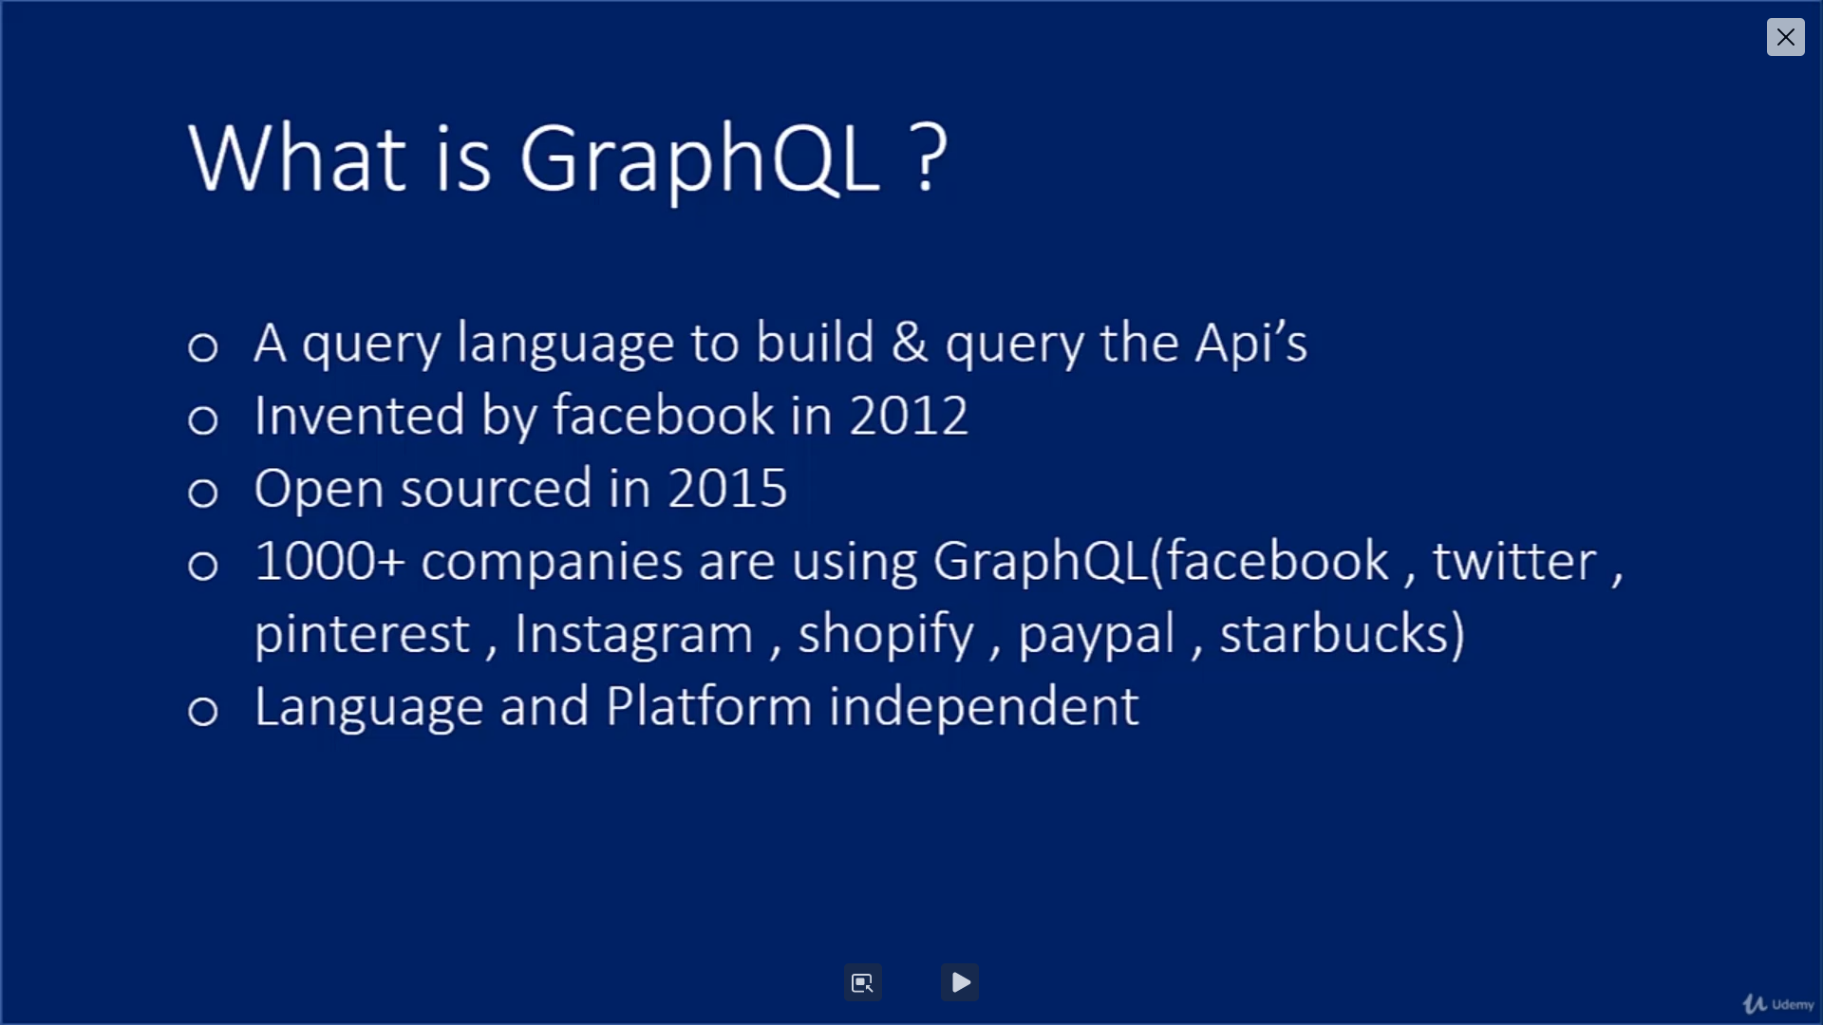

**Why We Need GraphQL**

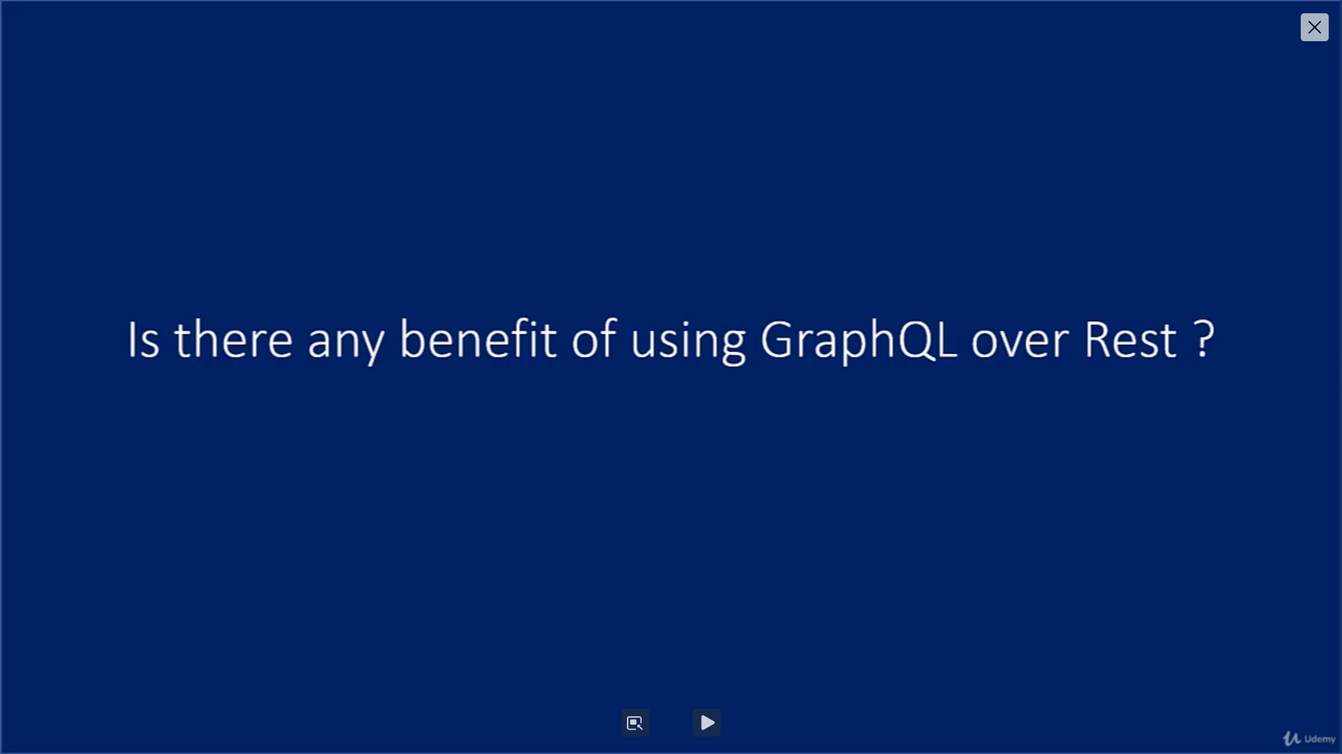

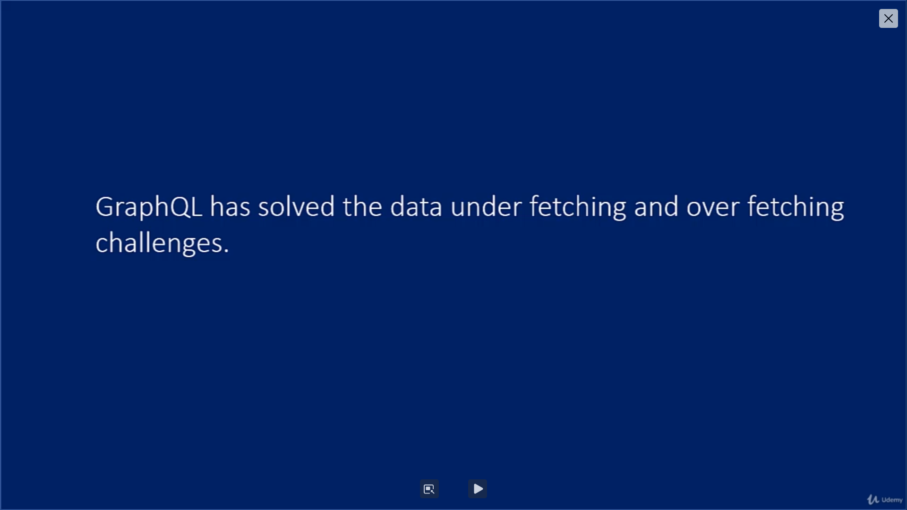

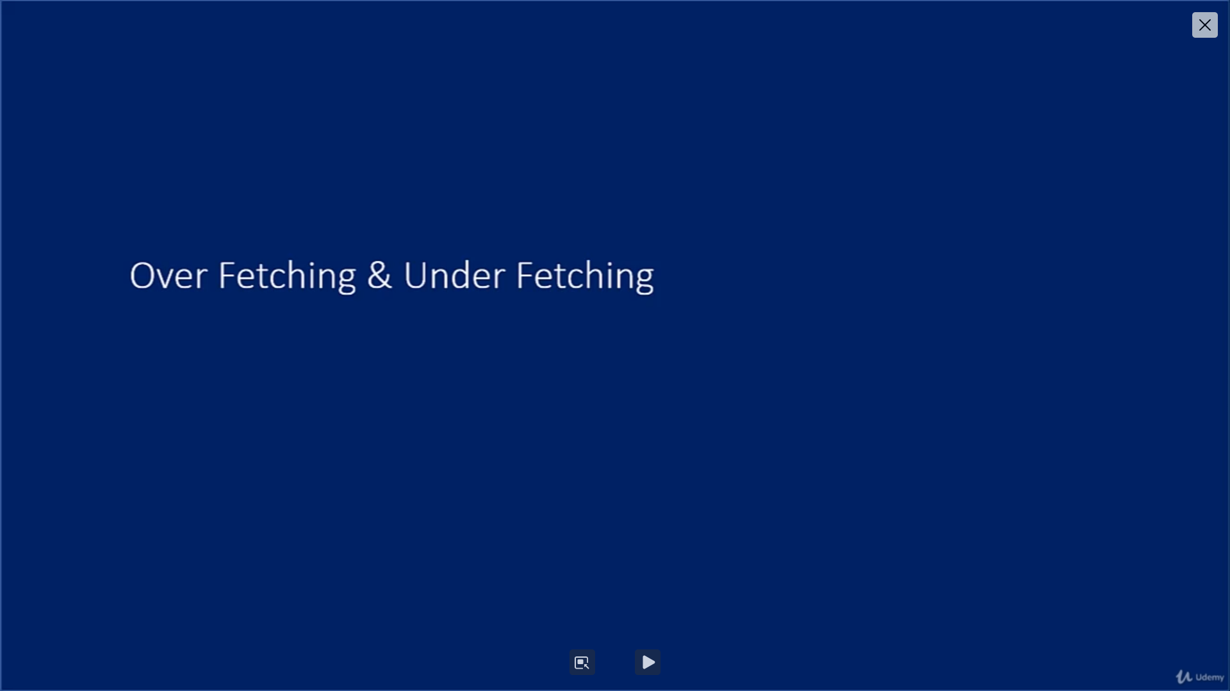

**Endpoints**

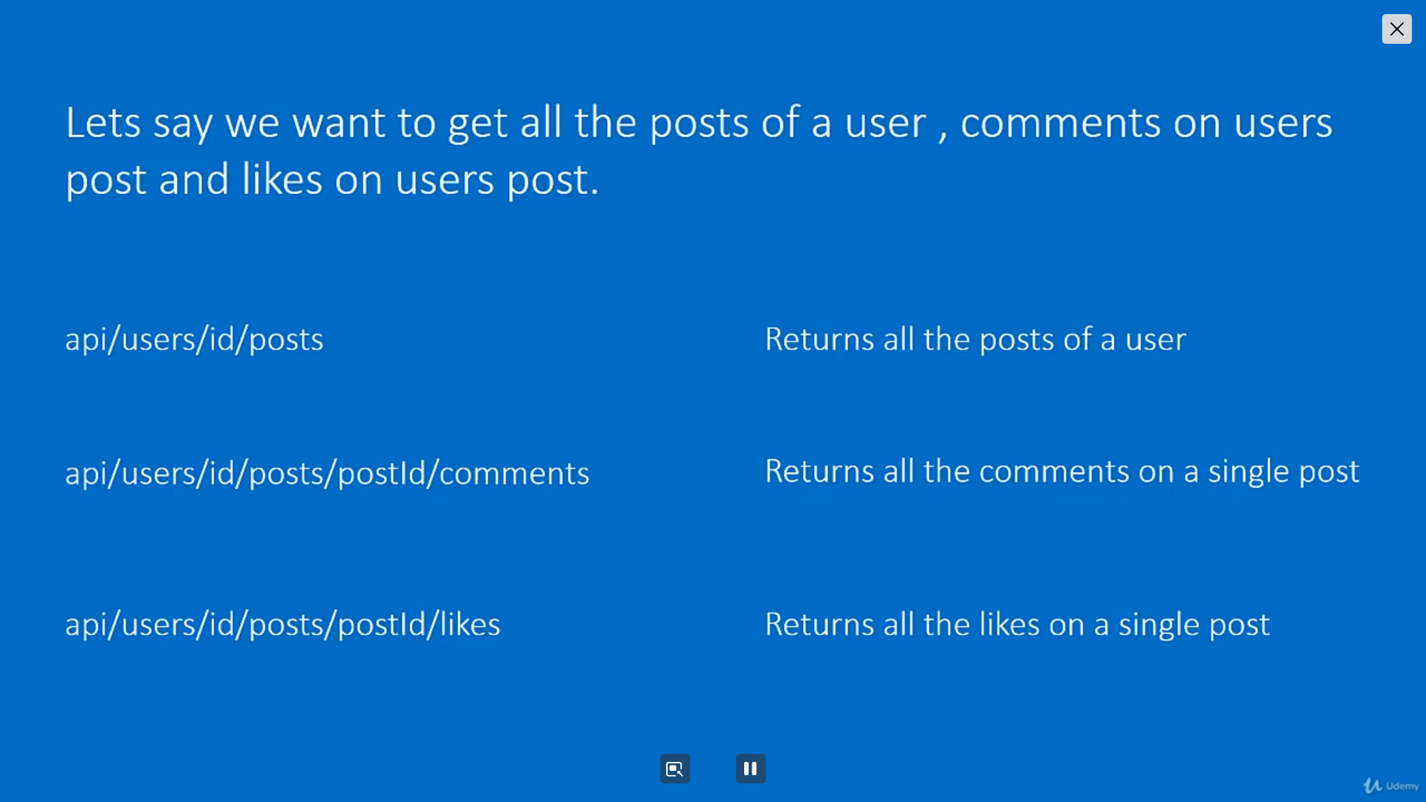

1. Incase when we used 3 end points in Rest Api for that have to create 3 Endpoints.
2. **Rather we are creating every endpoint it there any way to reduce the endpoints like One Endpoints it’s giving the all result in the JSON Payload.**
3. In such case we have to used GraphQL
4. It’s also Reduce the Payload size in most of the scenario we don’t want get all the json value in such case using GraphQL .
5. All the Endpoints call single db trip so it’s good for less Bandwidth it’s increase the Application Performance over the Rest API.

**Reduce the Payload**

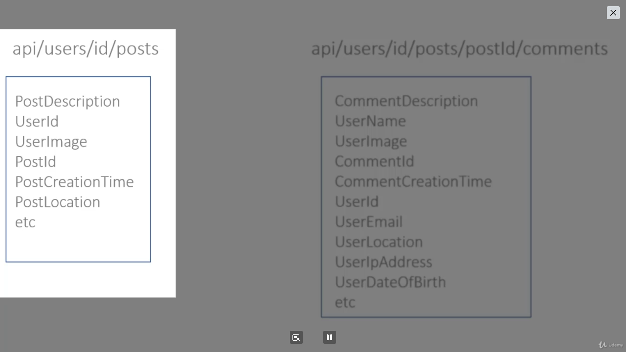

**Single Endpoint can perform all other endpoint job.**

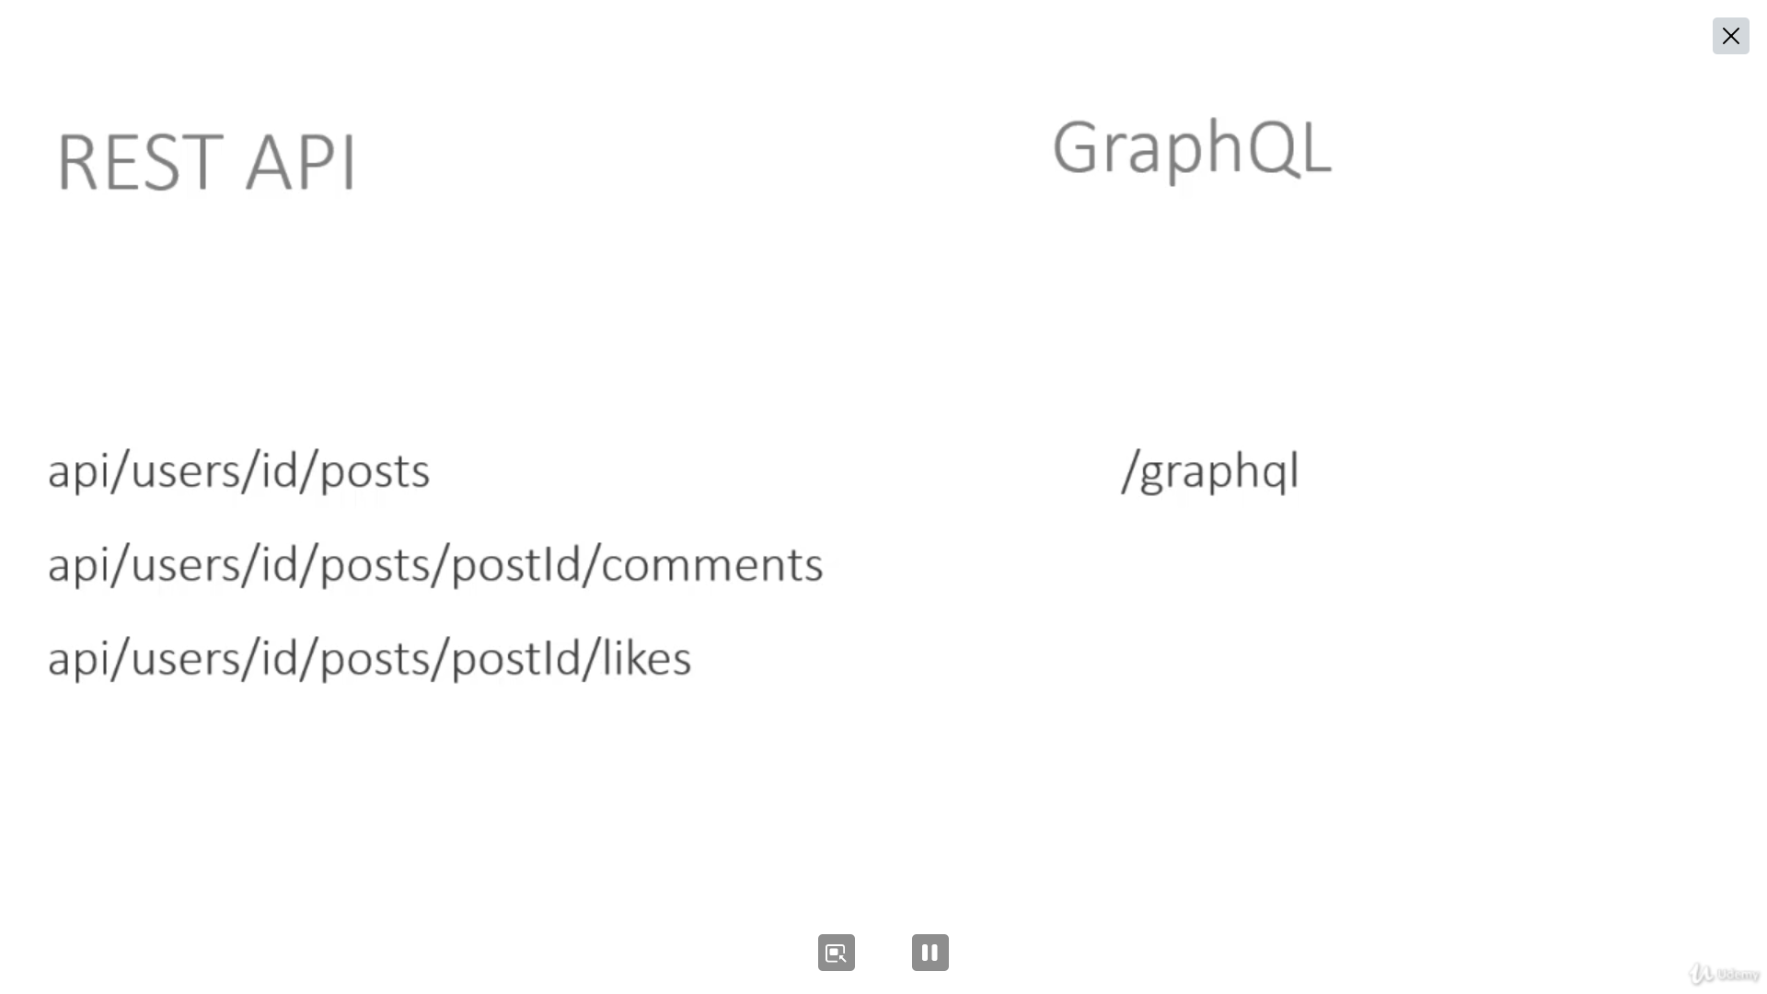

**One JSON Payload can return all other endpoint Result using Single Db Trip**

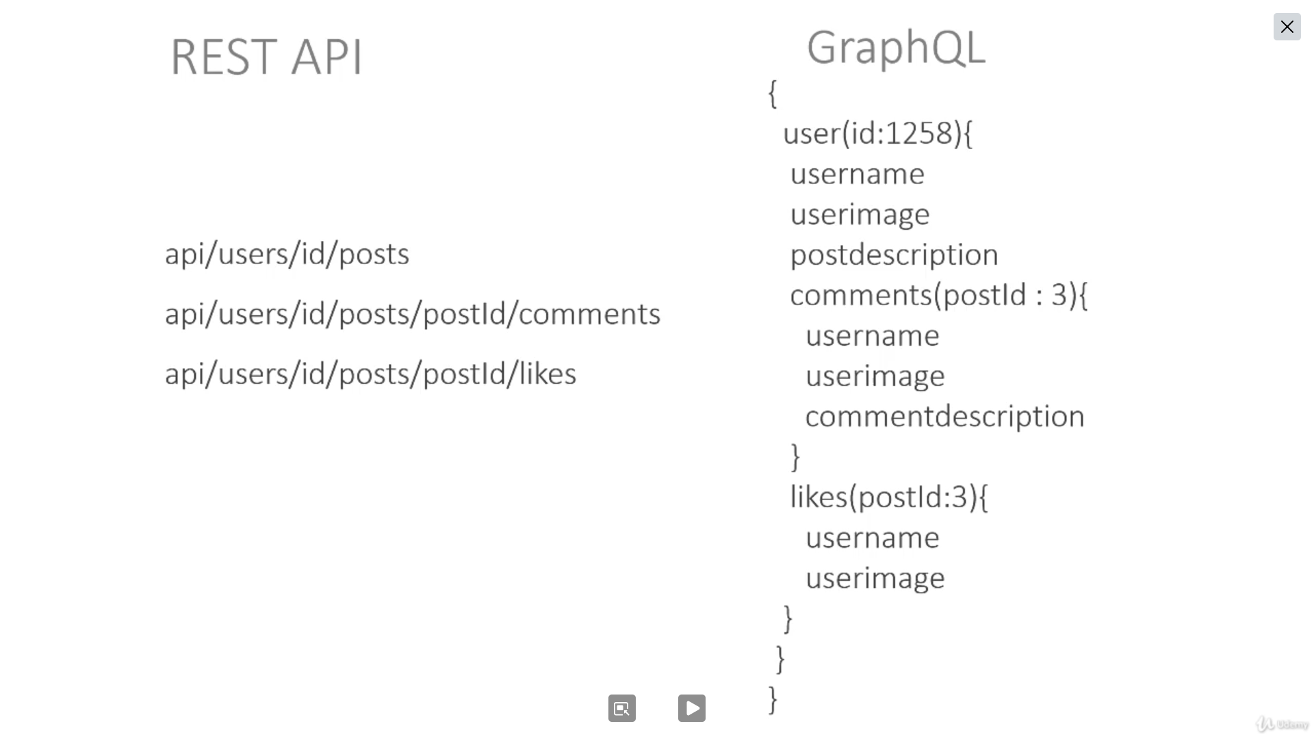

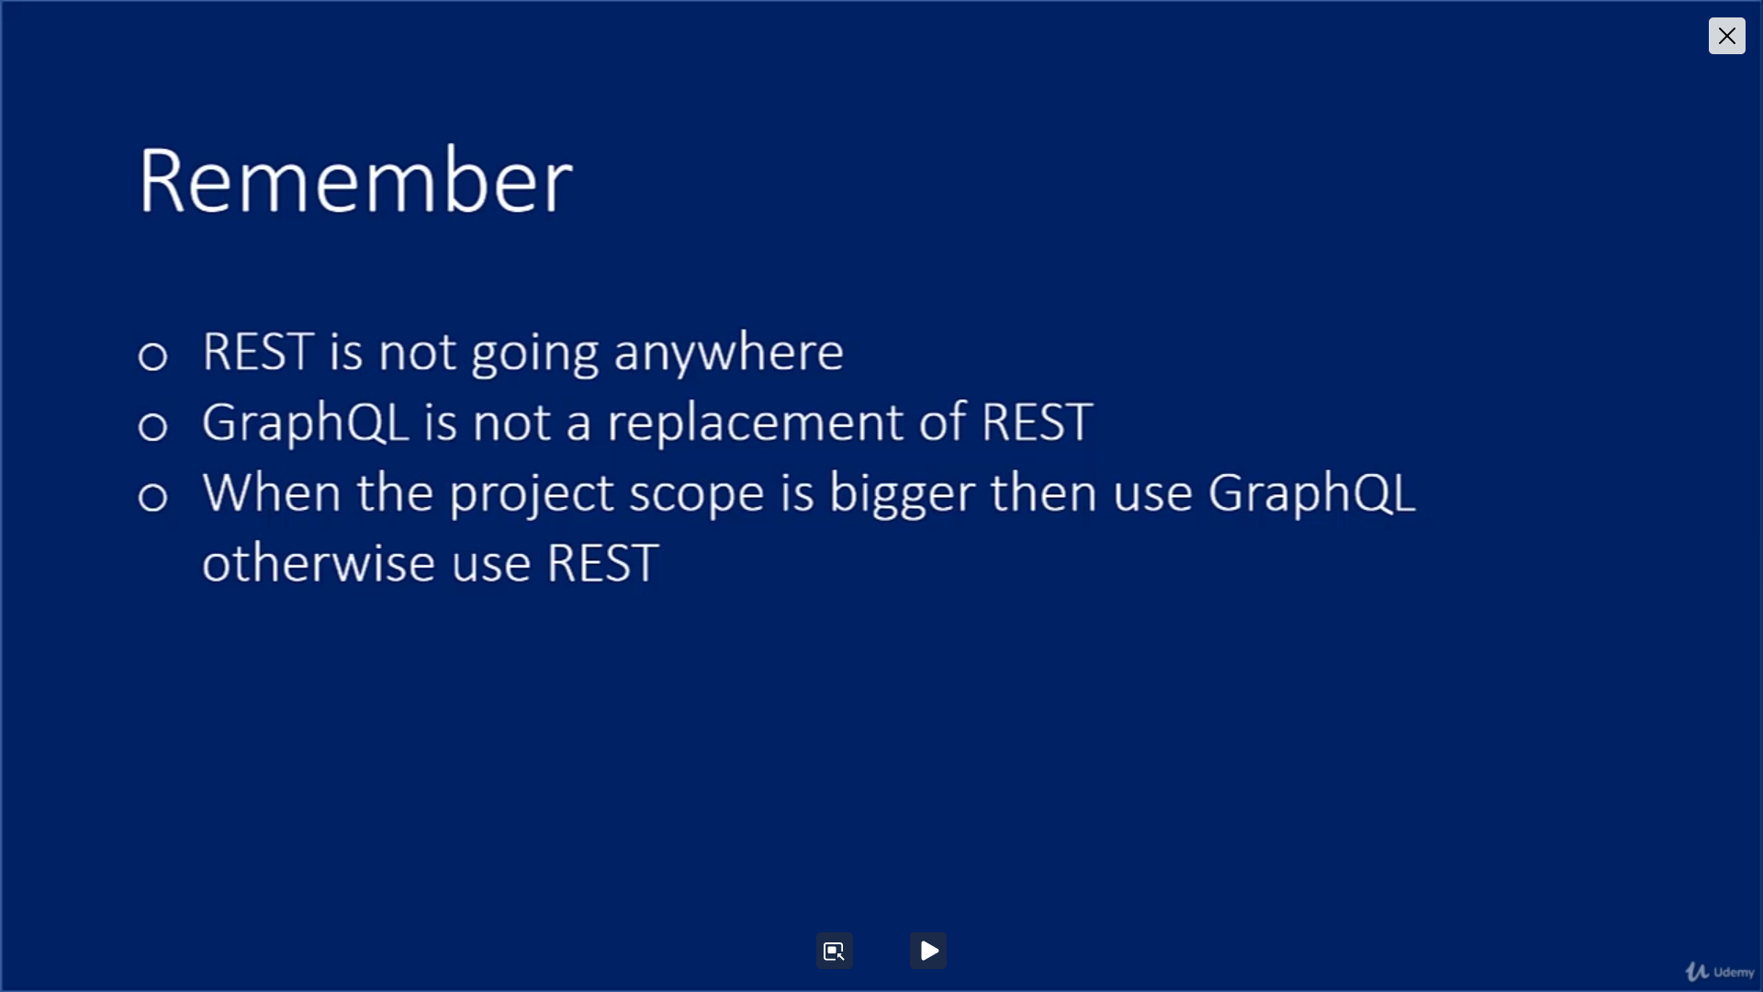

**GraphiQL with Github**

1. Navigate this site <https://docs.github.com/en/graphql/overview/explorer>
   1. Click on Sign in with GitUP Button
   2. Click on Authorize Git Up Button

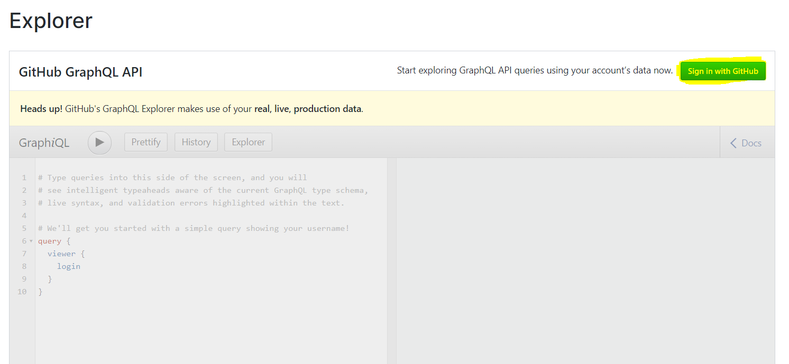

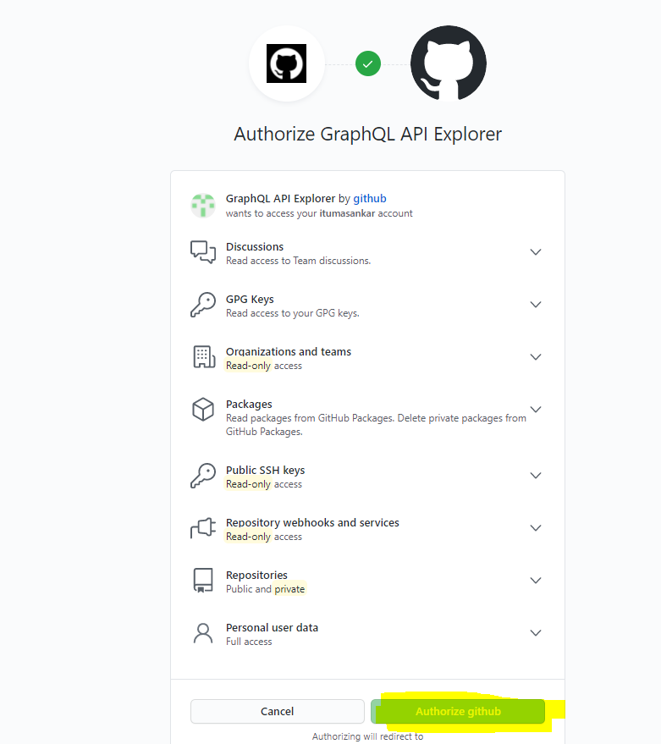

**Queries in GraphQL**

Follow above steps the Writing the Query

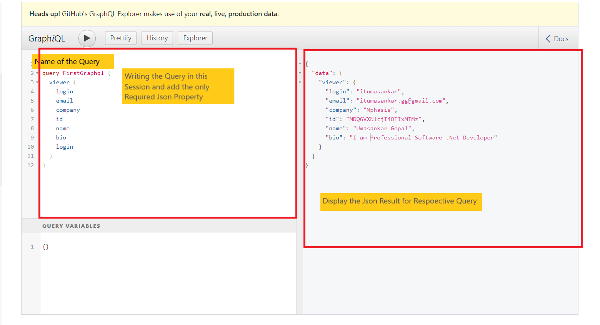

**Arguments in GraphQL**

If you want to pass argument for that below query, we can use.

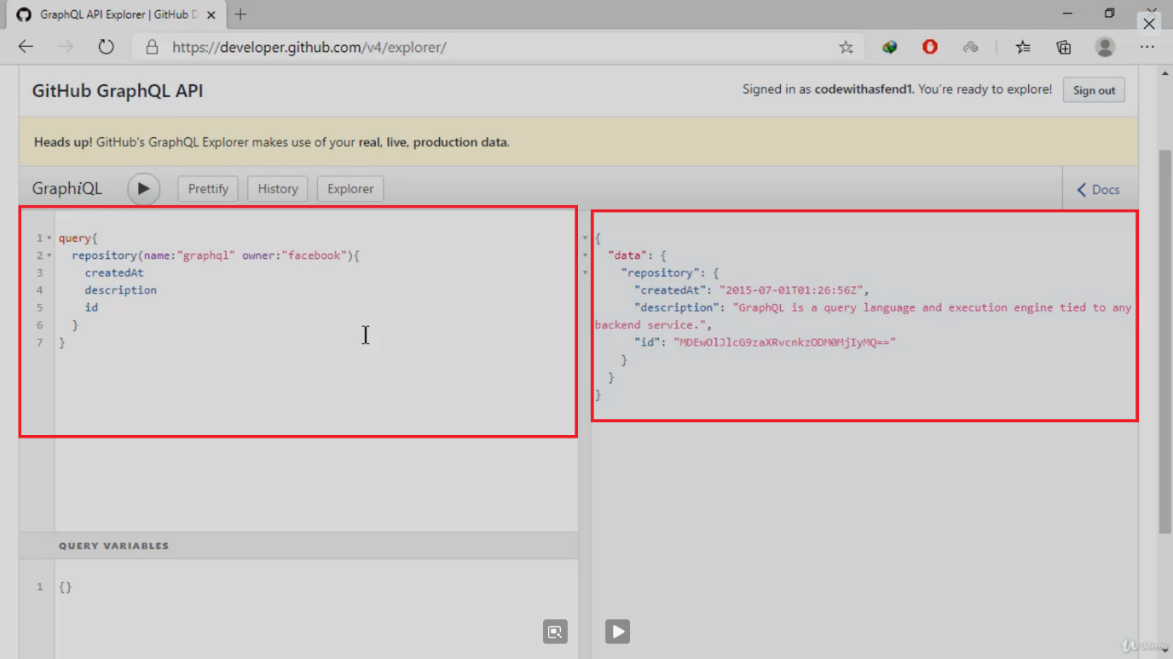

**Schemas in GraphQL**

* So graphical schema will tell us what this field is about, how to use queries.
* It also tells us what the argument will use to pass inside queries in.
* You can compare the graphical schema as an API documentation in any documentation.

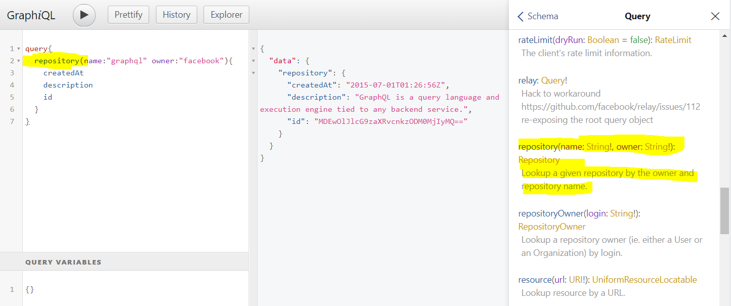

**Aliases in GraphQL**

If we want more permutation and combination of the same block. It’s showing some exception for avoiding that we could use Aliases

**Example**

If we want to duplicate same block with different value it will showing exception.

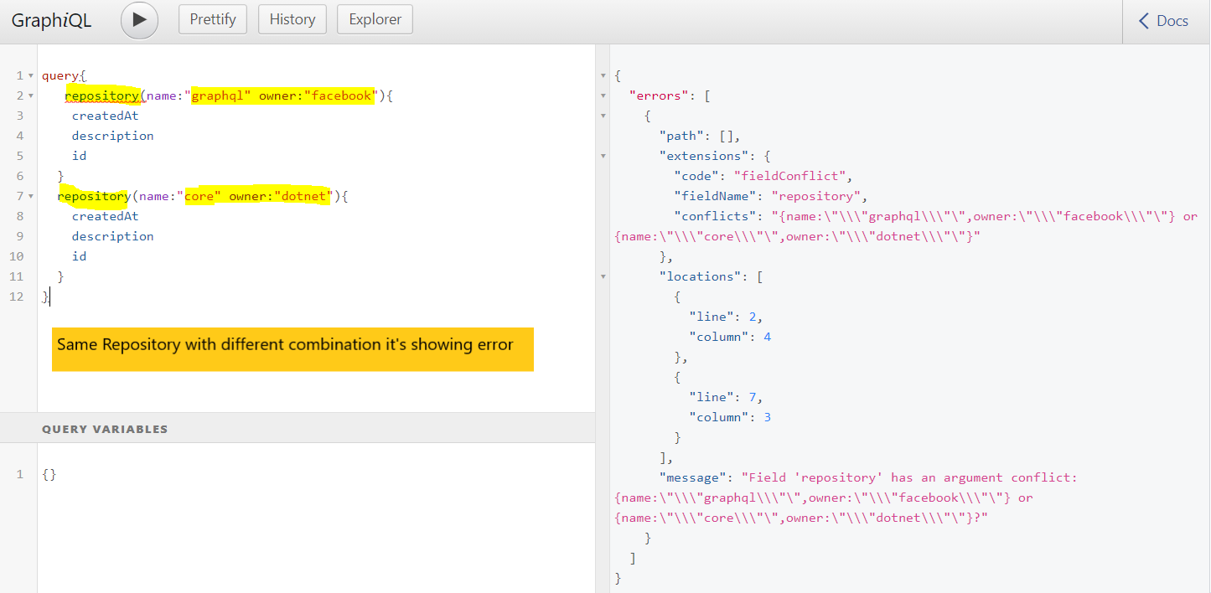

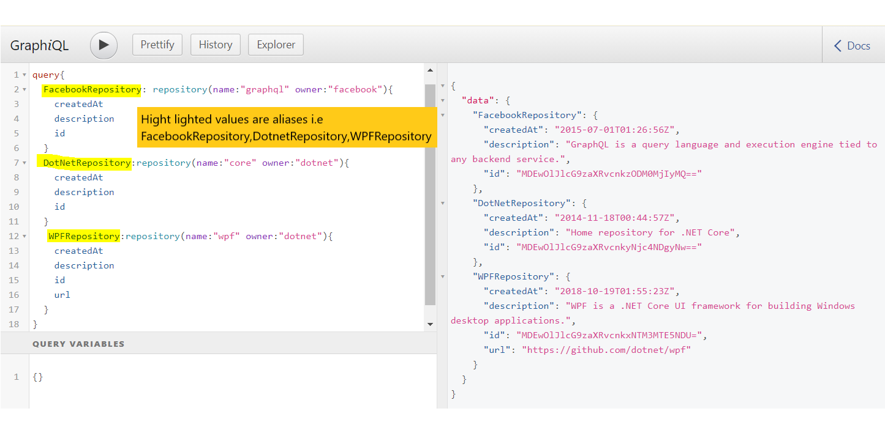

**Fragments in GraphQL**

If you don’t want add same field executing inside the query with different combination in this case fragment are used

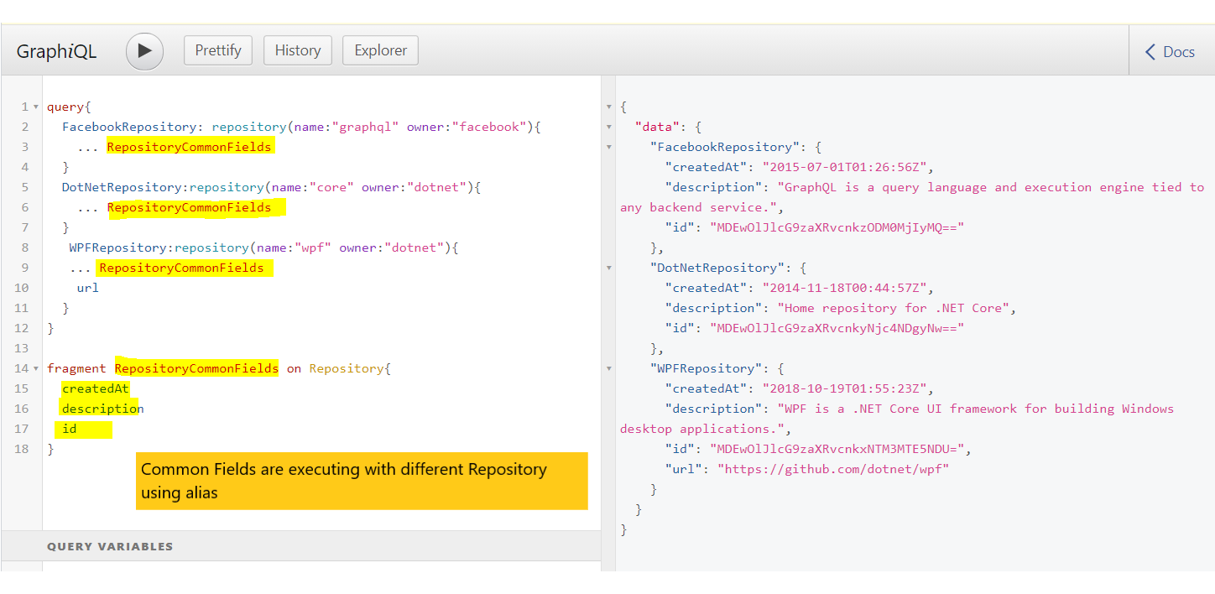

**Variables in GraphQL**

Rather we are assigning the hard value for avoiding that we could used

**KeyWords:**

$ 🡪 Variable assigning

! 🡪 Required

**Simple Variable Declaration**

Start with “$“and Name of the variable “:” what is the type of value if it is required then we use “!”

$name:String!

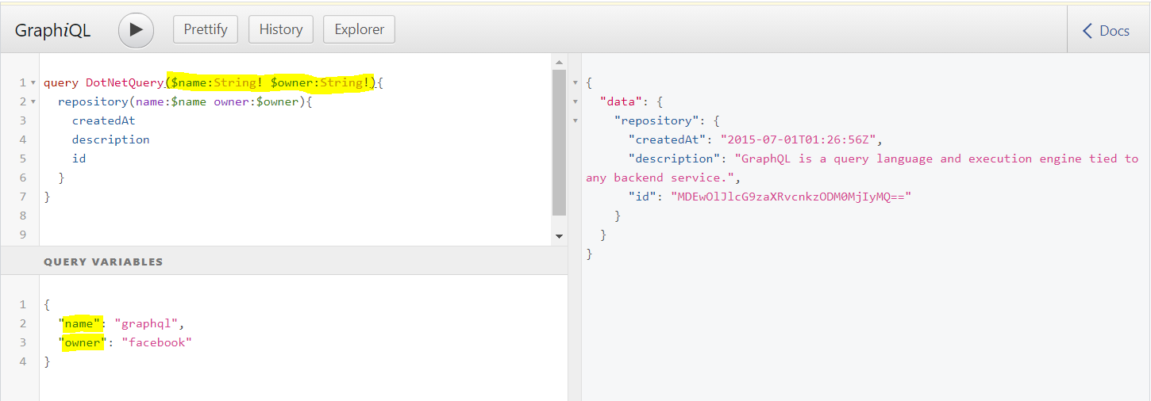

**Mutations in GraphQL**

* Mutations are nothing but the Post and Put and Delete Attribute in GraphQL
* Query are nothing but the Get Attribute in GraphQL

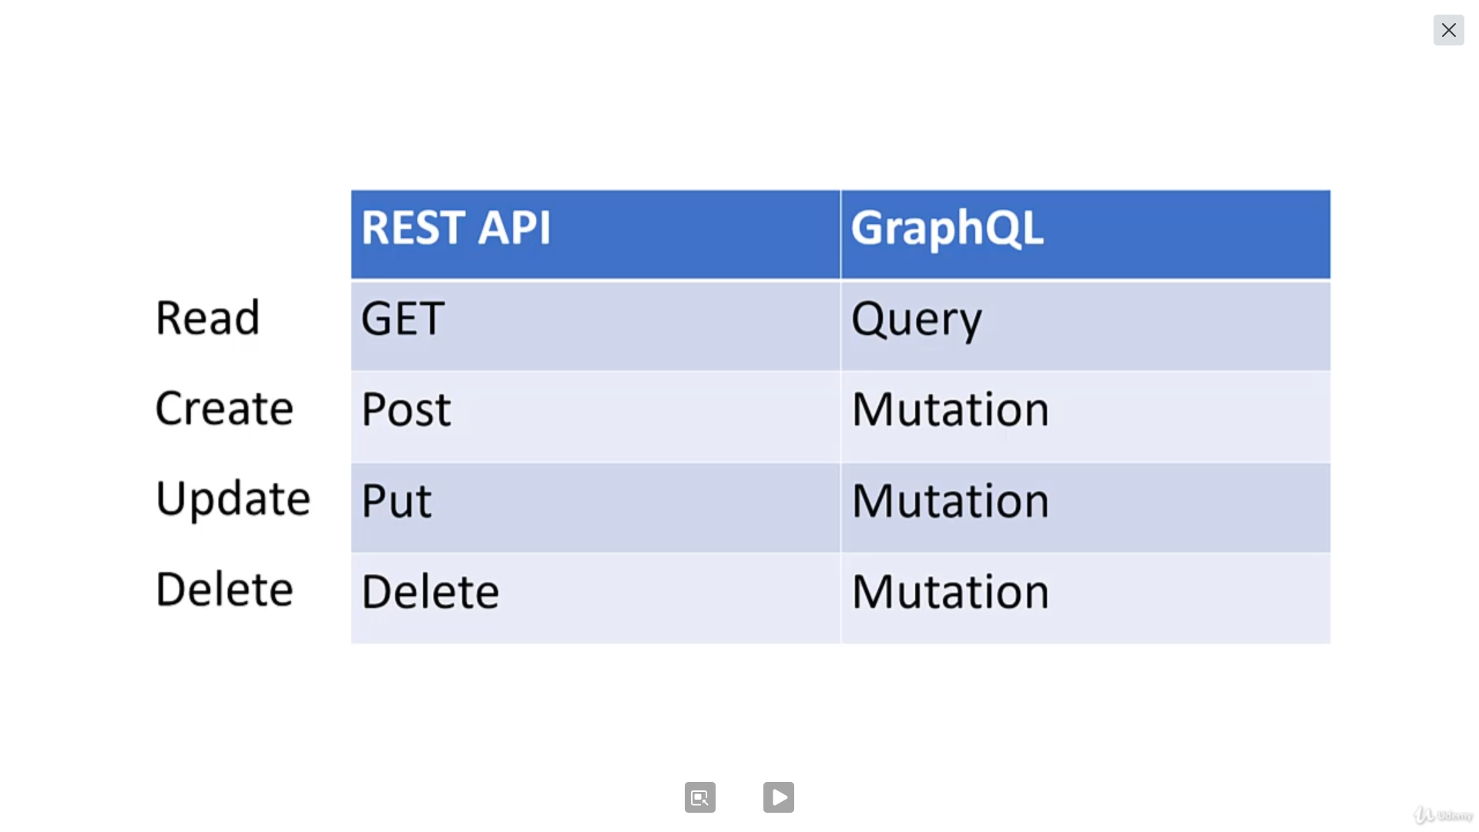

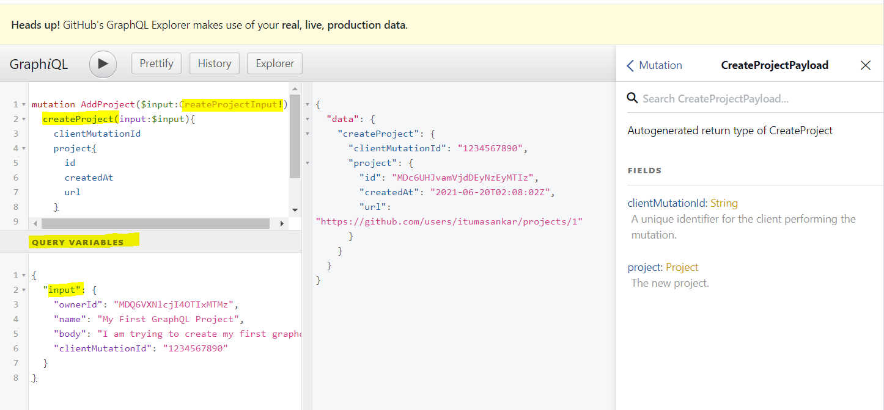

**Integration of GraphQL in .Net Core**

1. Install this Package in .net Core nuget Package “**GraphiQL**”
   1. It’s helps to install the play with **GraphQL** option in browser
2. Install this Package in .net Core nuget Package “**GraphQL.Server.Transports.AspNetCore.SystemTextJson**”

**Preparing the Project**

Adding below folder in our Project for Best Practices.

1. Type
2. Query
3. Schema
4. Mutation

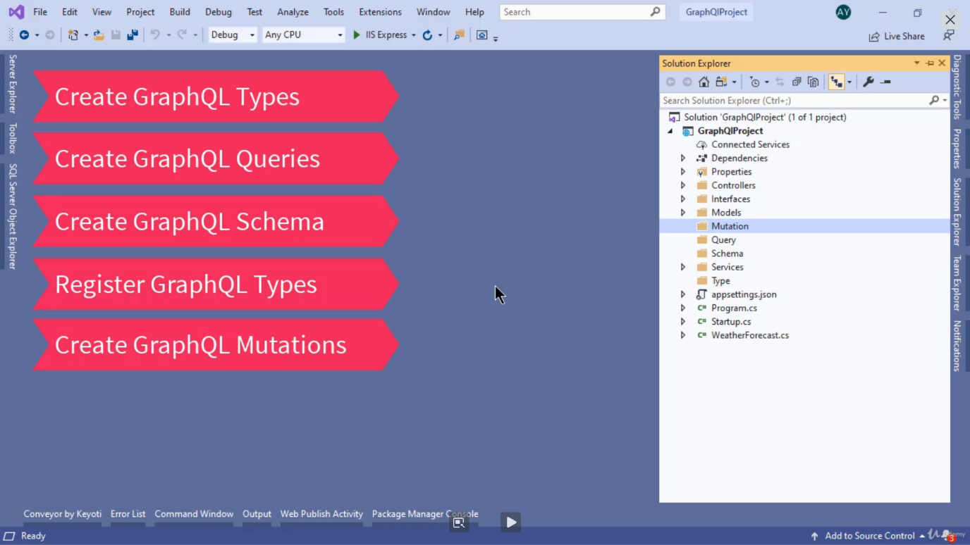

**GraphQL Types .Net Core**

If you want to understand our **graphql** our properties and give the intelligence we have to follow below steps.

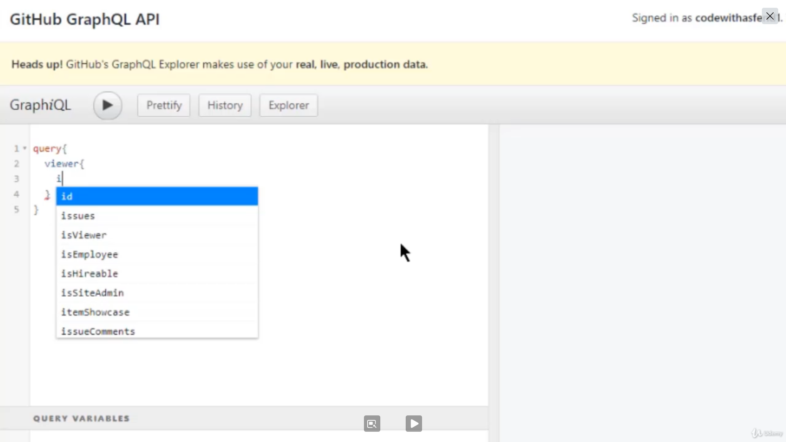

1. The graphical doesn't understand the seashell masterclasses.
2. It just understands the types.
3. It's important to remember that our graphical and points will have to return some data.
4. And currently we have a product model glass inside the model's folder.
5. And we need to map this class with a graphical type system so that the graphical can make the feels
6. according to our model glass.
7. Just good little folder and there is a new social class.

**GraphQL Queries .Net Core**

For below endpoint if we want to write the queries, we have to using this Return type we have follow the steps

1. **List<Product>**
   1. In Graph QL Doesn’t support **List** Operator for that we could use **ListGraphType** andalso, we have added the name of the query with resolve the operator.
   2. **GraphQL** doesn’t support the Controller so in case if we use in this project, we have to delete it.
   3. **Field**<**ListGraphType**<ProductType>>("**products**", resolve: context=> { return productService.GetAllProducts(); });
2. **Product GetProductById(int id)**
   1. If we want to return the concrete model in **GraphQL** we have to use the Type and name of the query with arguments
      1. In this argument we have to mention the name of the Property with Resolve Argument
         1. Here if your parameter as **int** then we have to use **IntGraphType**

Field<ProductType>("product", arguments: new QueryArguments(new QueryArgument<IntGraphType> { Name = "id" }),

resolve: context =>

{

return productService.GetProductById(context.GetArgument<int>("id"));

});

**GraphQL Schemas .Net Core**

**In Schemas handling 2 things**

* 1. Query
  2. Mutation

public ProductSchema(ProductQuery productQuery)

{

Query = productQuery;

}

**Configure GraphQL Server**

Register Type, Query, Schema under the

**ConfigureServices Method**

public void ConfigureServices(IServiceCollection services)

{

services.AddTransient<ProductType>();

services.AddTransient<ProductQuery>();

services.AddTransient<ISchema, ProductSchema>();

services.AddGraphQL(options =>

{

options.EnableMetrics = false;

}).AddSystemTextJson();

}

**Configure Method**

app.UseGraphiQl("/graphql"); // GraphQl UI

app.UseGraphQL<ISchema>();

**Test GraphQL Queries**

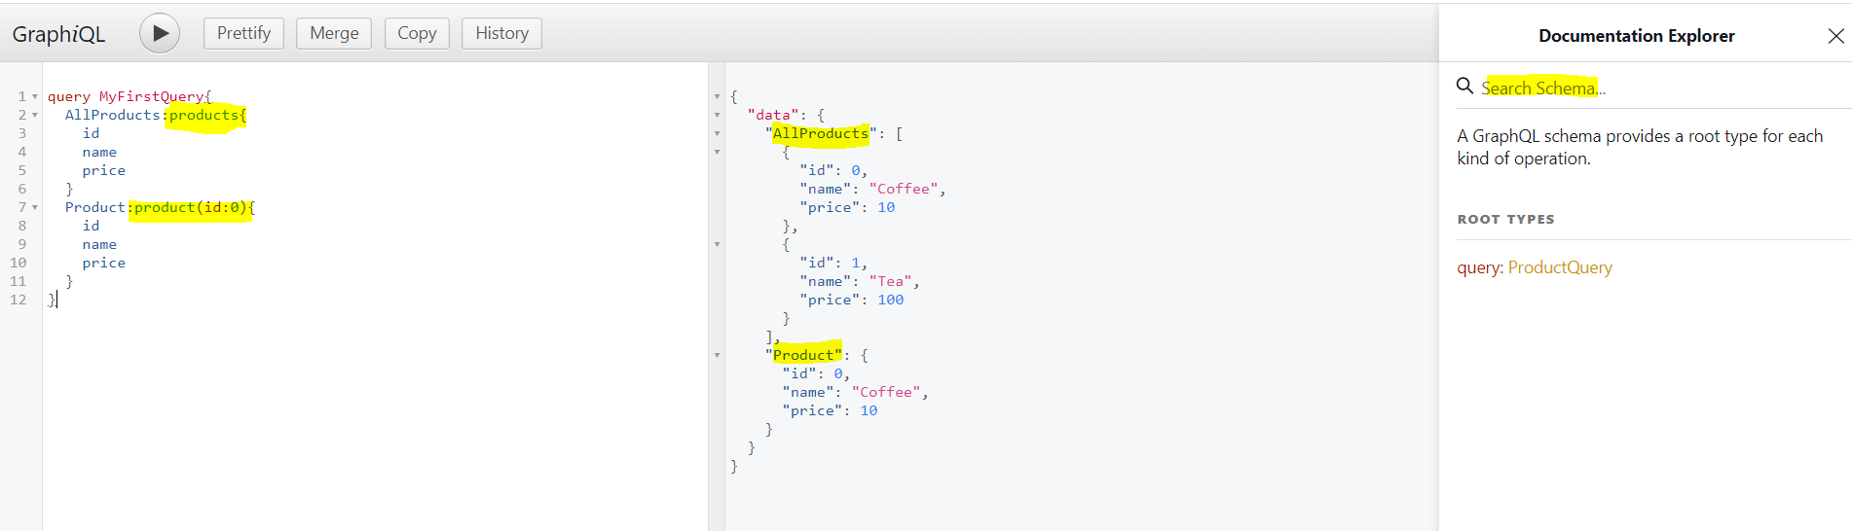

**GraphQL Mutations .Net Core**

If want to create mutation follow below step,

1. if we passed input parameter as view model for that, we have to create **InputType** because **graphql** doesn’t understand our model class.
2. In **Schema** we have assign mutation is our model because Schema handles mutation and query.
3. **Startup.cs** under **ConfigureServices** method we add **DI** FOR OUR Mutation class.

Step 1: ProductInputType

public ProductInputType()

{

Field<IntGraphType>("id");

Field<StringGraphType>("name");

Field<FloatGraphType>("price");

}

Step 2: ProductMutation

public ProductMutation(IProduct productService)

{

Field<ProductType>("createProduct", arguments: new QueryArguments(new QueryArgument<ProductInputType> { Name = "product" }),

resolve: context =>

{

return productService.AddProduct(context.GetArgument<Product>("product"));

});

Field<ProductType>("updateProduct",

arguments: new QueryArguments(new QueryArgument<IntGraphType> { Name = "id" },

new QueryArgument<ProductInputType> { Name = "product" }),

resolve: context =>

{

var productObj = context.GetArgument<Product>("product");

var productId = context.GetArgument<int>("id");

return productService.UpdateProduct(productId, productObj);

});

Field<StringGraphType>("deleteProduct",

arguments: new QueryArguments(new QueryArgument<IntGraphType> { Name = "id" }),

resolve: context =>

{

var productId = context.GetArgument<int>("id");

productService.DeleteProduct(productId);

return "The product against the" + productId + "has been deleted";

});

}

**GraphQL Test Mutations**

**Add:**

mutation AddProduct($product:ProductInputType){

createProduct(product:$product){

id

name

price

}

}

Outer Variable

{

"product": {

"id": 2,

"name": "Mango juice",

"price": 12

}

}

**Update:**

mutation UpdateProduct($id:Int,$product:ProductInputType){

updateProduct(id:$id,product:$product){

id

name

price

}

}

Outer Variable

{

"product": {

"id": 1,

"name": "Mango juice",

"price": 12

}

}

**Delete:**

mutation DeleteProduct($id:Int){

deleteProduct(id:$id)

}

Outer Variable

{

"id": 1

}

**Root query:**

In Scheme it’s support only one Query. In case if we want to execute multiple query statement then We have to use **Root query**.

**Example:**

public class RootSchema : GraphQL.Types.Schema

{

public RootSchema(IServiceProvider serviceProvider) : base(serviceProvider)

{

Query = serviceProvider.GetRequiredService<RootQuery>();

Mutation = serviceProvider.GetRequiredService<RootMutation>();

}

}

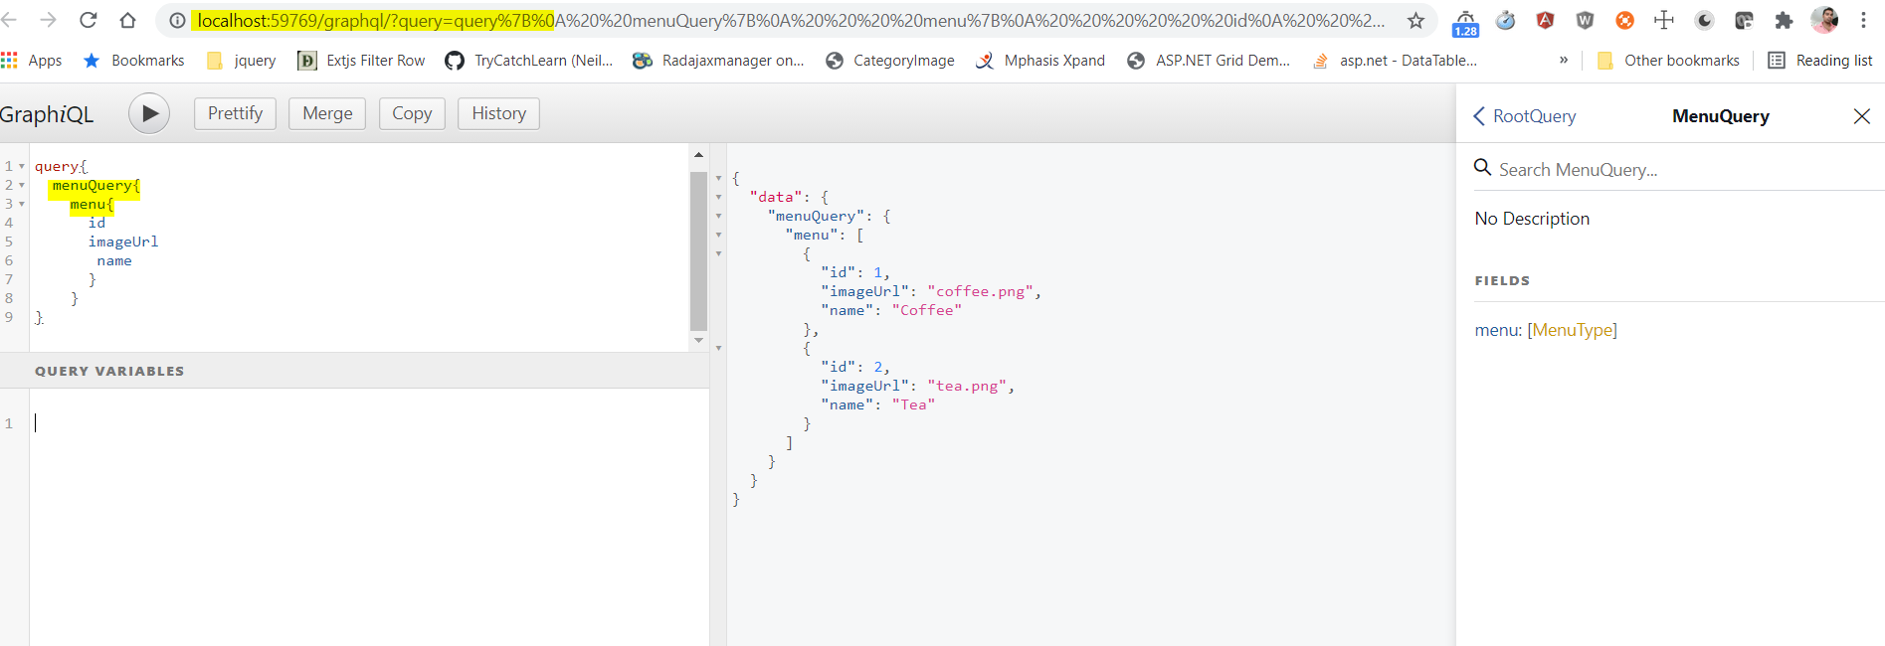

**Menu Query:**

query{

menuQuery{

menu{

id

imageUrl

name

}

}

}

**Sub Menu Query:**

query{

submenuQuery{

submenu{

id

imageUrl

name

description

price

menuId

}

}

}

**Reservation Query:**

query{

reservationQuery{

reservation{

id

name

phone

totalPhone

email

date

time

}

}

}

**Root Mutation:**

In Scheme it’s support only one Mutation. In case if we want to execute Mutation query statement then We have to use **Root Mutation**.

**Example:**

public class RootSchema : GraphQL.Types.Schema

{

public RootSchema(IServiceProvider serviceProvider) : base(serviceProvider)

{

Query = serviceProvider.GetRequiredService<RootQuery>();

Mutation = serviceProvider.GetRequiredService<RootMutation>();

}

}

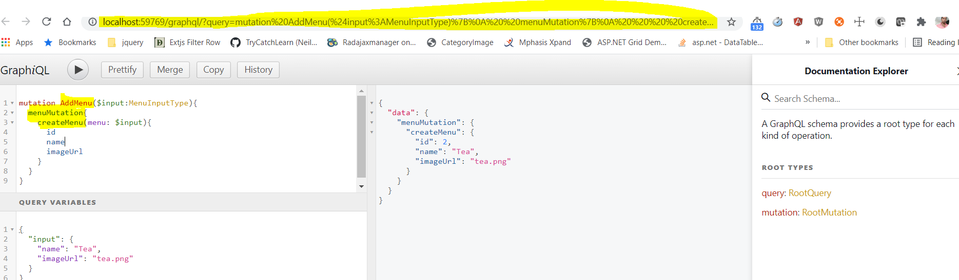

**Menu Query:**

mutation AddMenu($input:MenuInputType){

menuMutation{

createMenu(menu: $input){

id

name

imageUrl

}

}

}

**Sub Menu Query:**

mutation **AddSubMenu**($input:SubMenuInputType){

**submenuMutation**{

createSubMenu(subMenu:$input)

{

id

description

menuId

imageUrl

name

price

}

}

}

**Query Variables:**

{

"input": {

"name": "Leamon Tea",

"description": "Added with some ingredients",

"imageUrl": "Leamontea.png",

"price": 50,

"menuId": 2

}

}

**Reservation Query:**

query{

reservationQuery{

reservation{

id

name

phone

totalPhone

email

date

time

}

}

}

**Query Variables:**

{

"input": {

"name": "Jeni",

"phone": "91765589",

"totalPhone": 1,

"email": "jenidev@gmail.com",

"date": "27 Jully 2021",

"time": "08:07 PM"

}

**Nested Query:**

1. In case if we model has more navigation property like one-to-many object, we need to display in single json payload.
2. For that in Rest API we can write more query and pass the values and assign the appropriate model for Instead of doing that we could use **GraphQL**.
3. Its helps to highly reusable code.

**Example:**

**If the Menu have list to Submenu in this case we are using below code.**

**Step 1:**

Copy the Code into **SubMenu** Query with Pass some Parent ID

**Step 2:**

Paste those code into **Menu** Type and Run it.

**Code:**

**SubMenu:**

public class SubMenuQuery : ObjectGraphType

{

public SubMenuQuery(ISubMenu subMenu)

{

// Copy this line and paste into Menu Type

Field<ListGraphType<SubMenuType>>("submenu", resolve: context => { return subMenu.GetSubMenus(); });

Field<ListGraphType<SubMenuType>>("submenuById", arguments:

new QueryArguments(new QueryArgument<IntGraphType> { Name = "id" }),

resolve: context =>

{

return subMenu.GetMenus(context.GetArgument<int>("id"));

});

}

}

**MenuType:**

public class MenuType : ObjectGraphType<Menu>

{

public MenuType(ISubMenu subMenu)

{

Field(m => m.Id);

Field(m => m.ImageUrl);

Field(m => m.Name);

// Paste the Code and pass the values appropriate values

Field<ListGraphType<SubMenuType>>("submenu", resolve: context => { return subMenu.GetMenus(context.Source.Id); });

}

}

**Model Property to Input Type Conversion**

|  |  |
| --- | --- |
| Model Property | Input Type |
| int | IntGraphType |
| string | StringGraphType |
| double | FloatGraphType |
|  |  |
|  |  |
|  |  |
|  |  |
|  |  |

**Reference Project:**

1. C:\Study Drive\Practise\Dot Net Core\GraphQL\Coffe Shop Project\GraphQLProject
2. C:\Study Drive\Practise\Dot Net Core\GraphQL\GraphQLProject

**Graphql Hot Chocolate**

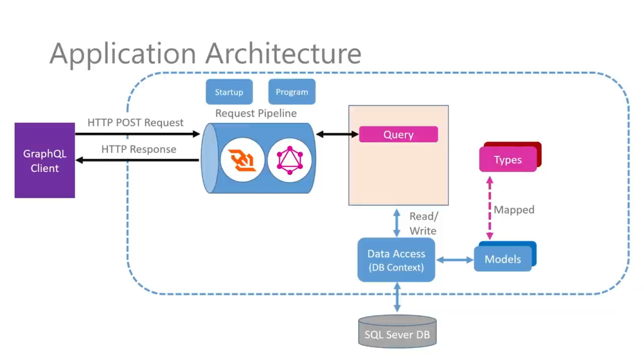

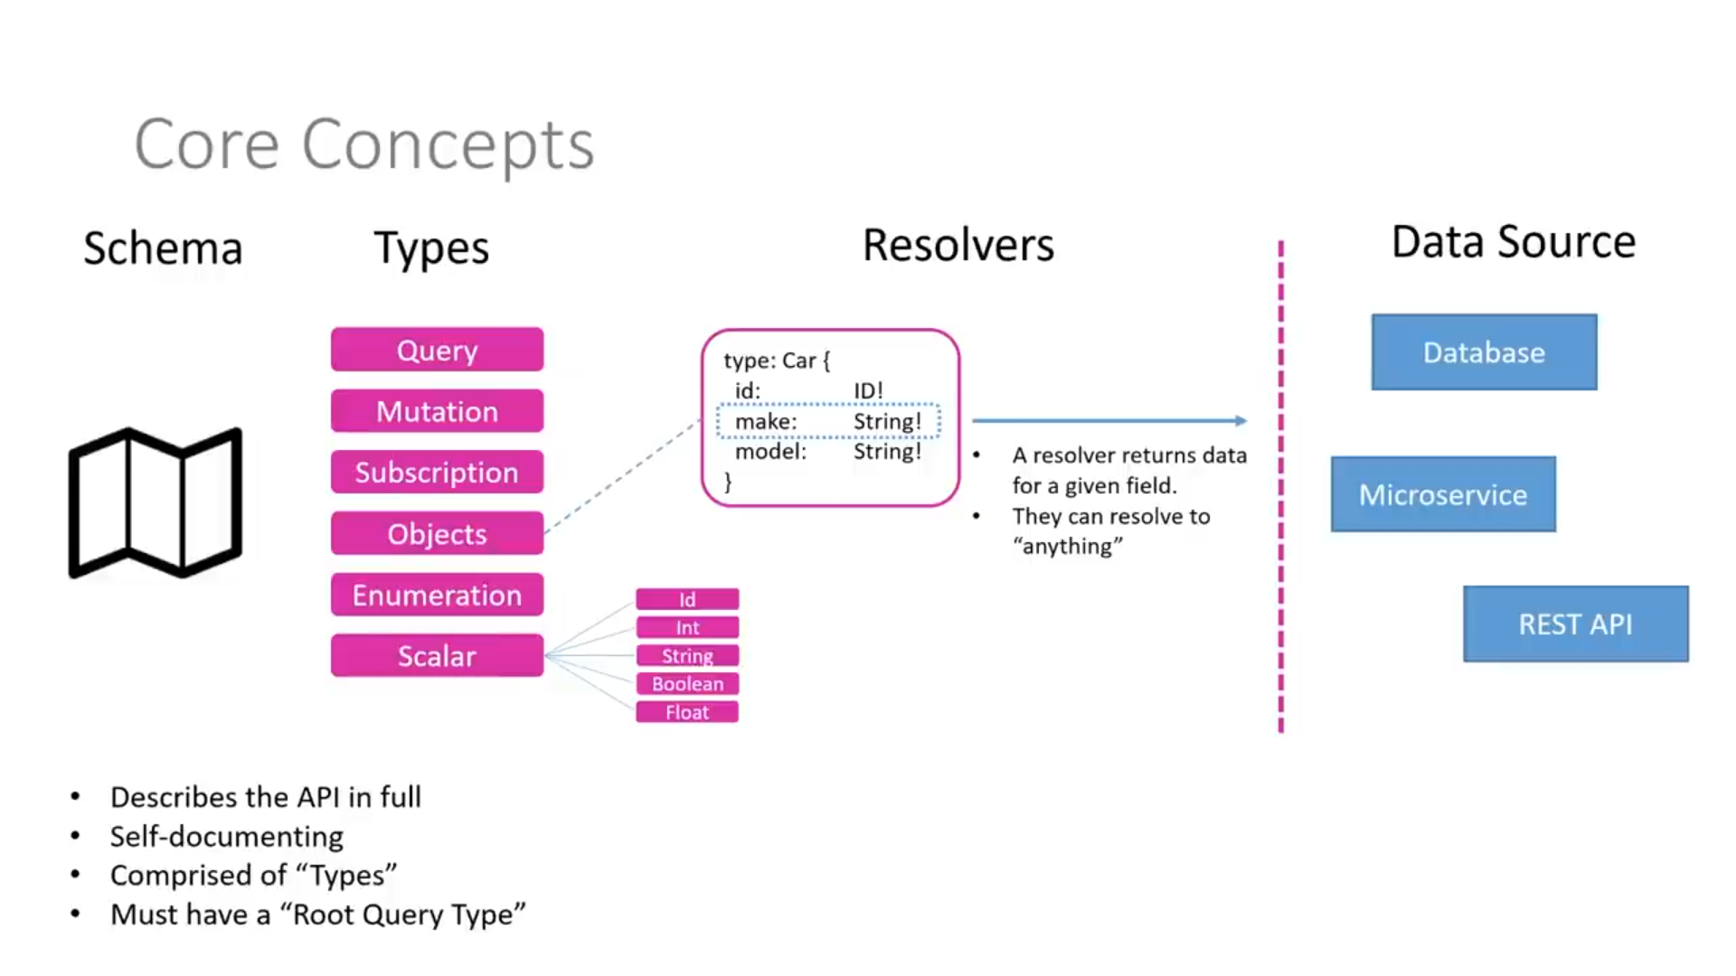

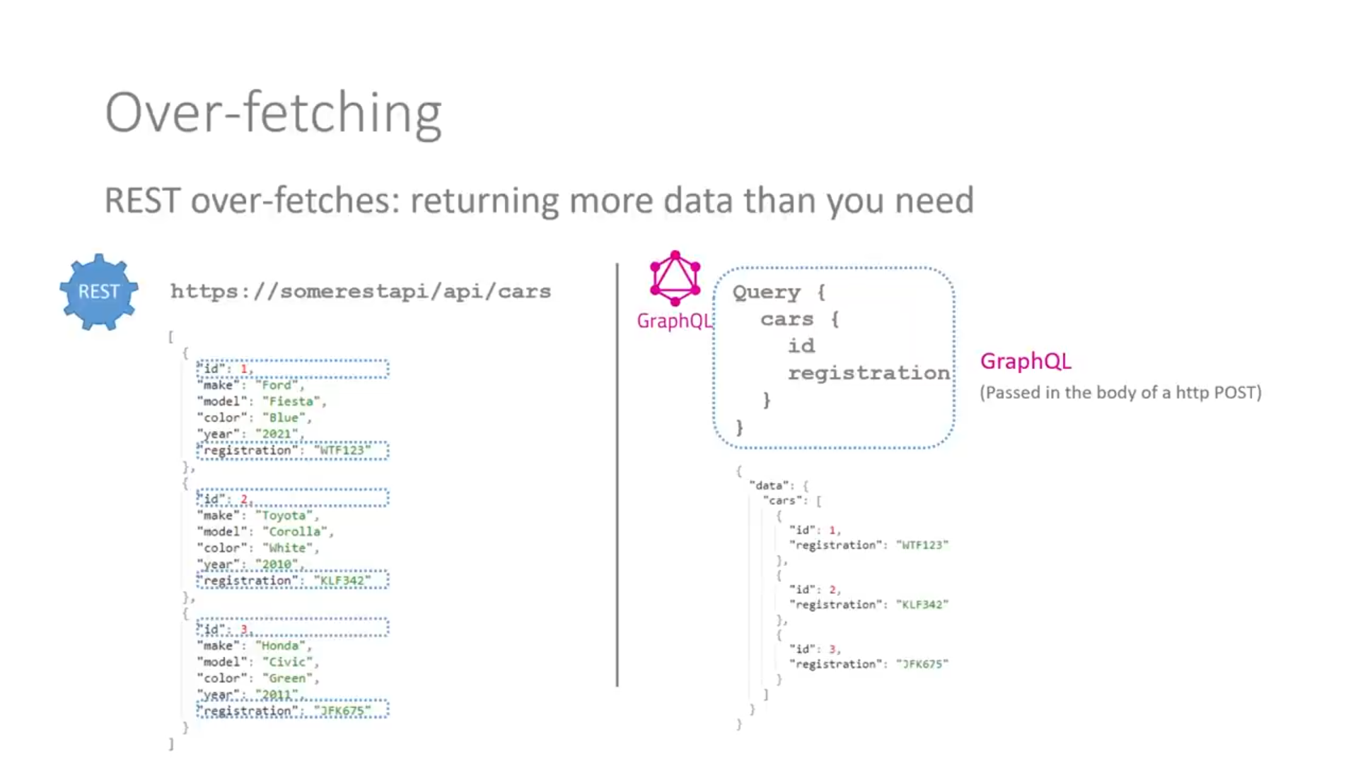

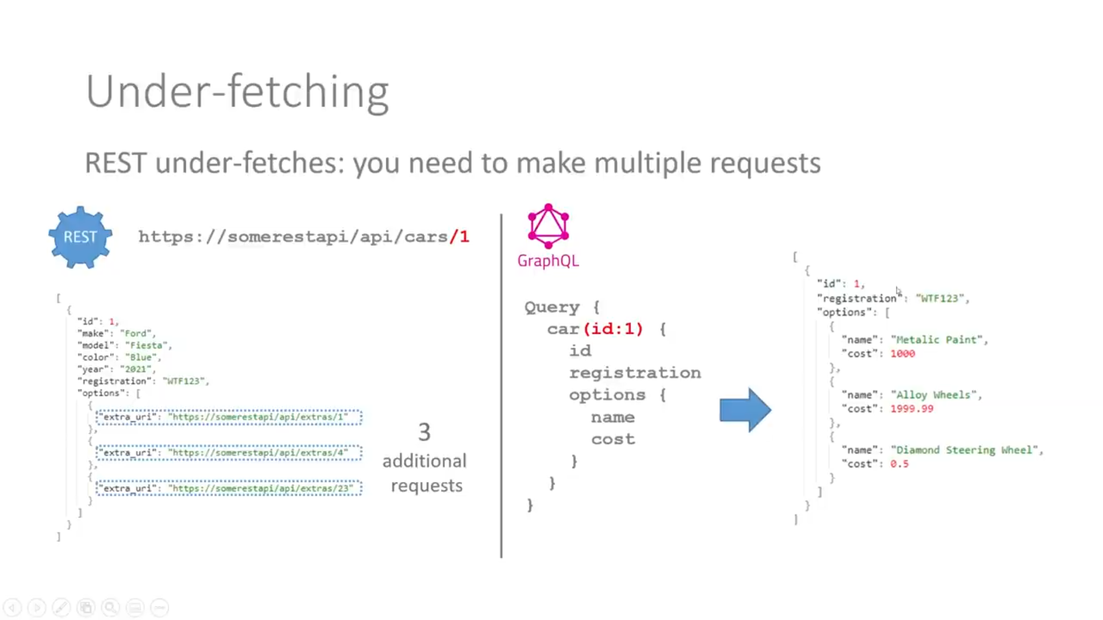

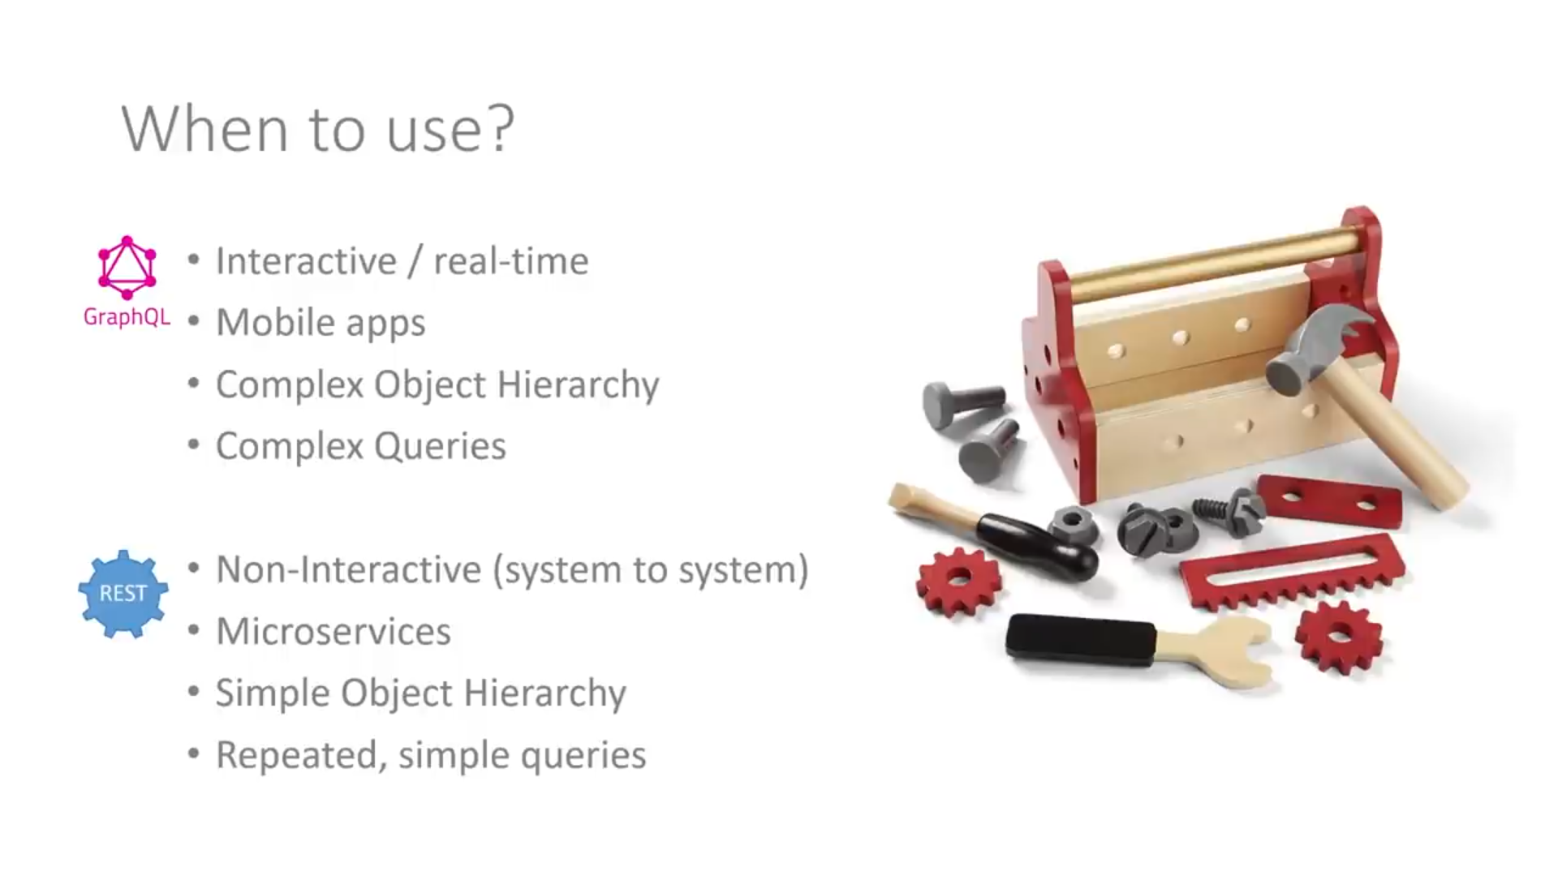

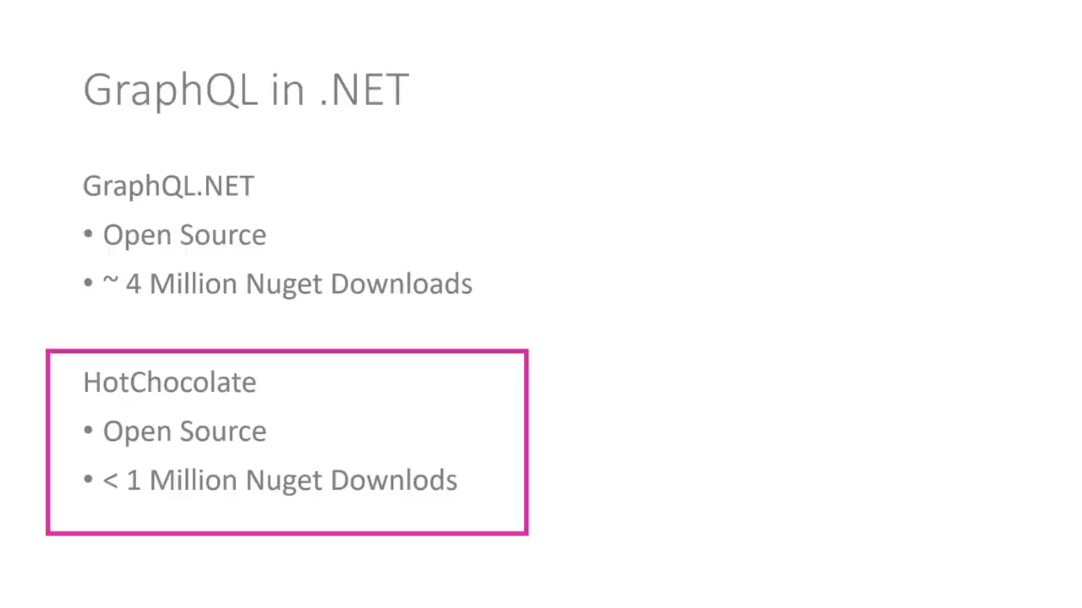

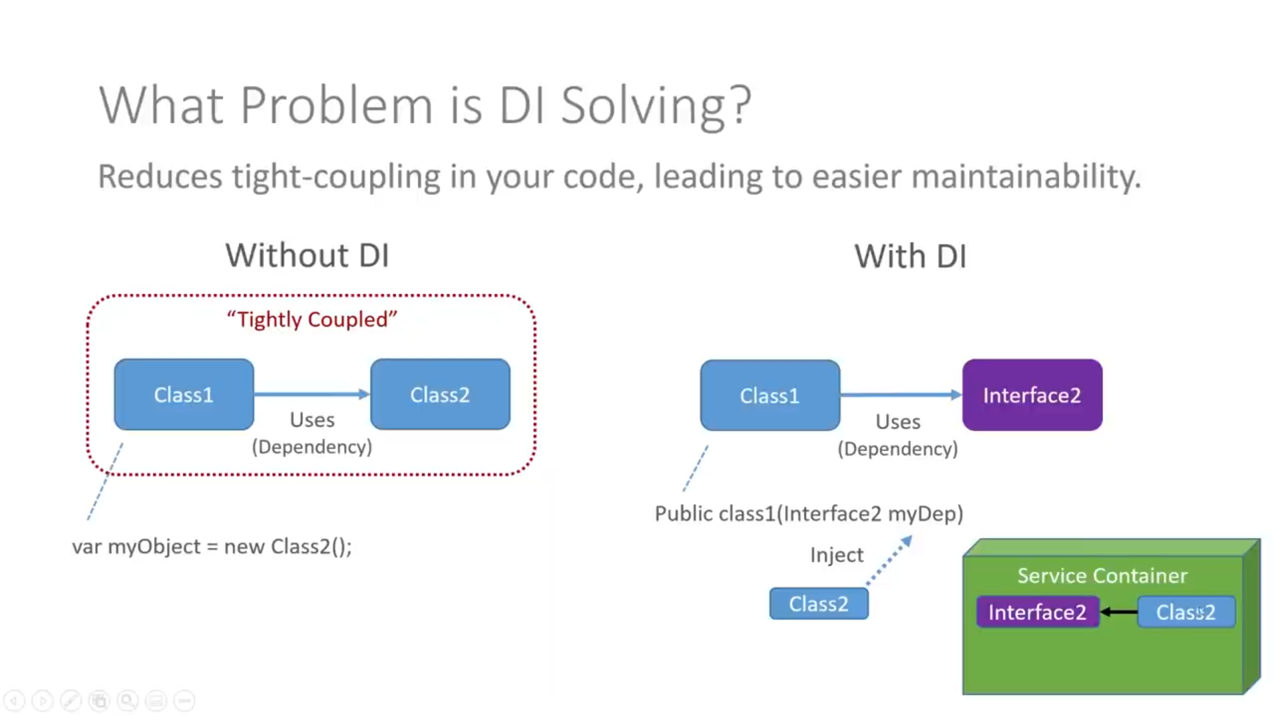

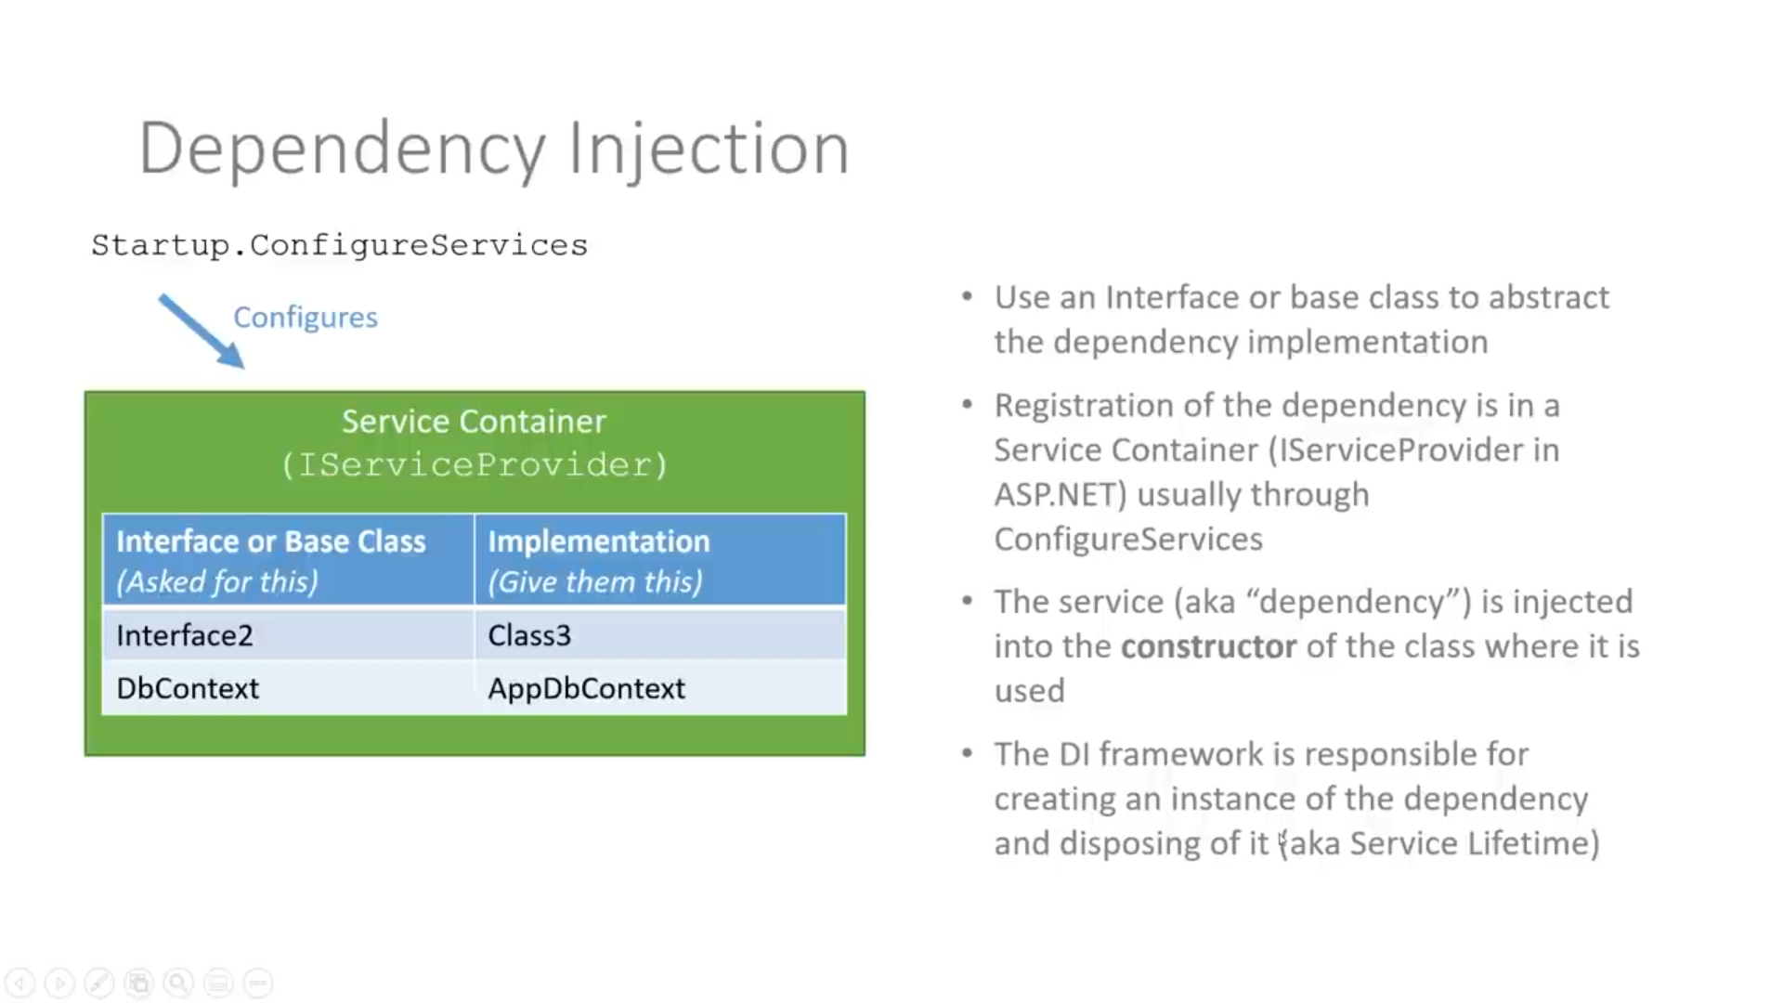

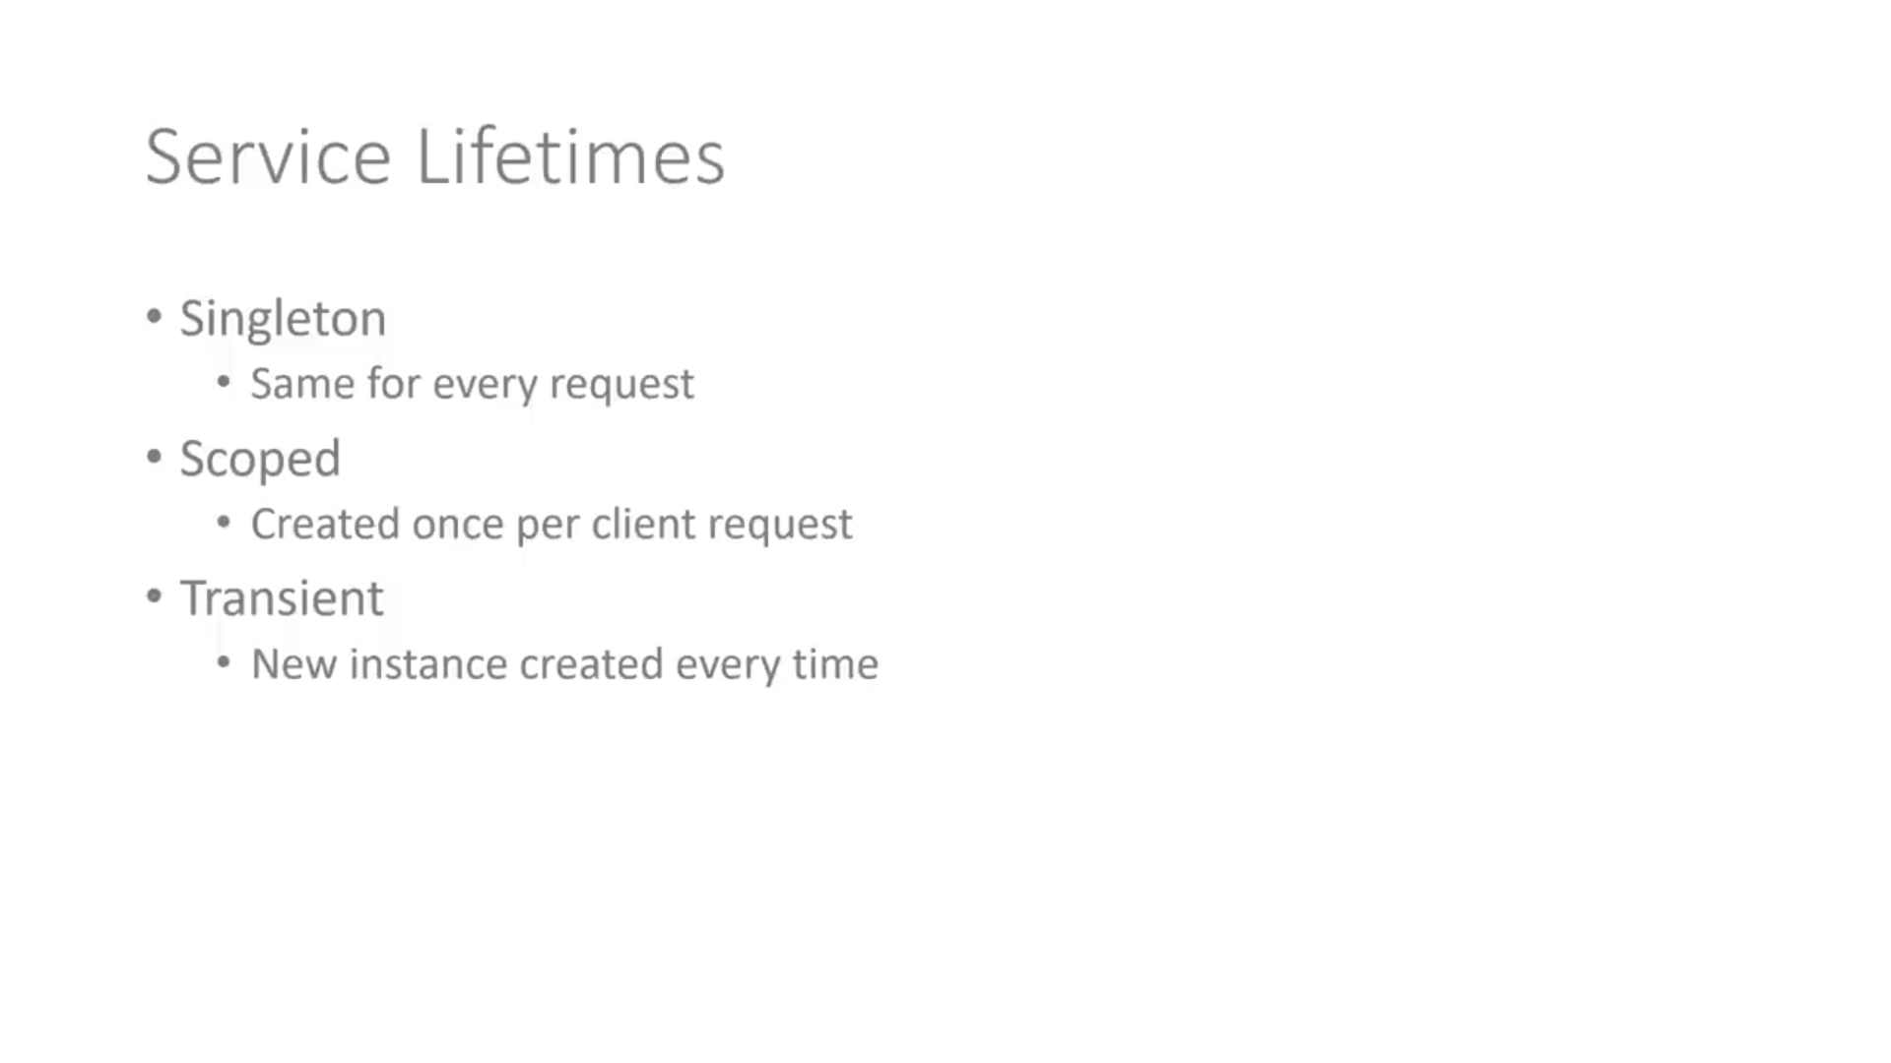

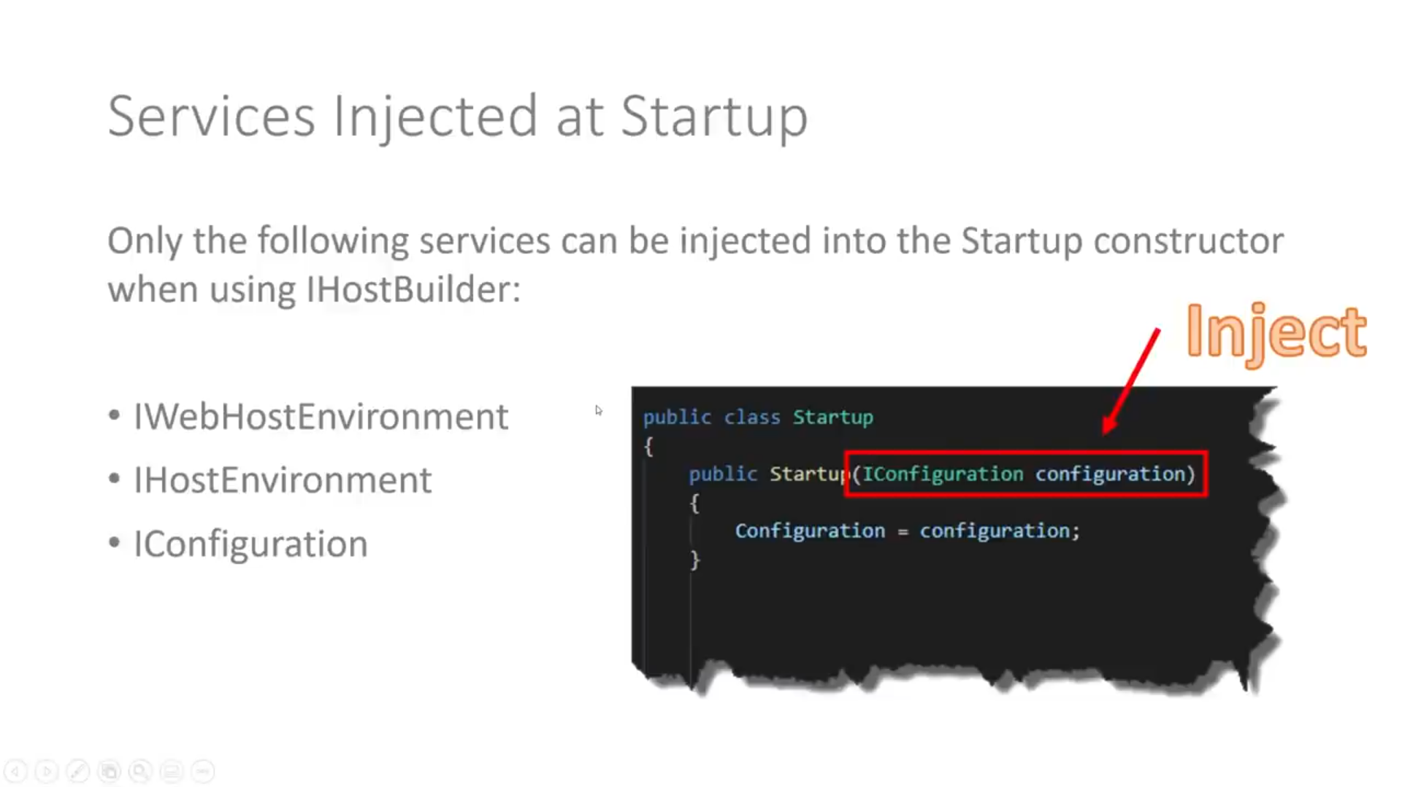

**/graphql-voyager:**

It’s helps identity object Relationships. It’s helps to when we add documentation.

// it's helps schema documentation, with out this one also it will run

app.UseGraphQLVoyager(new GraphQLVoyagerOptions()

{

GraphQLEndPoint = "/graphql",

Path = "/graphql-voyager"

});

**Example:**

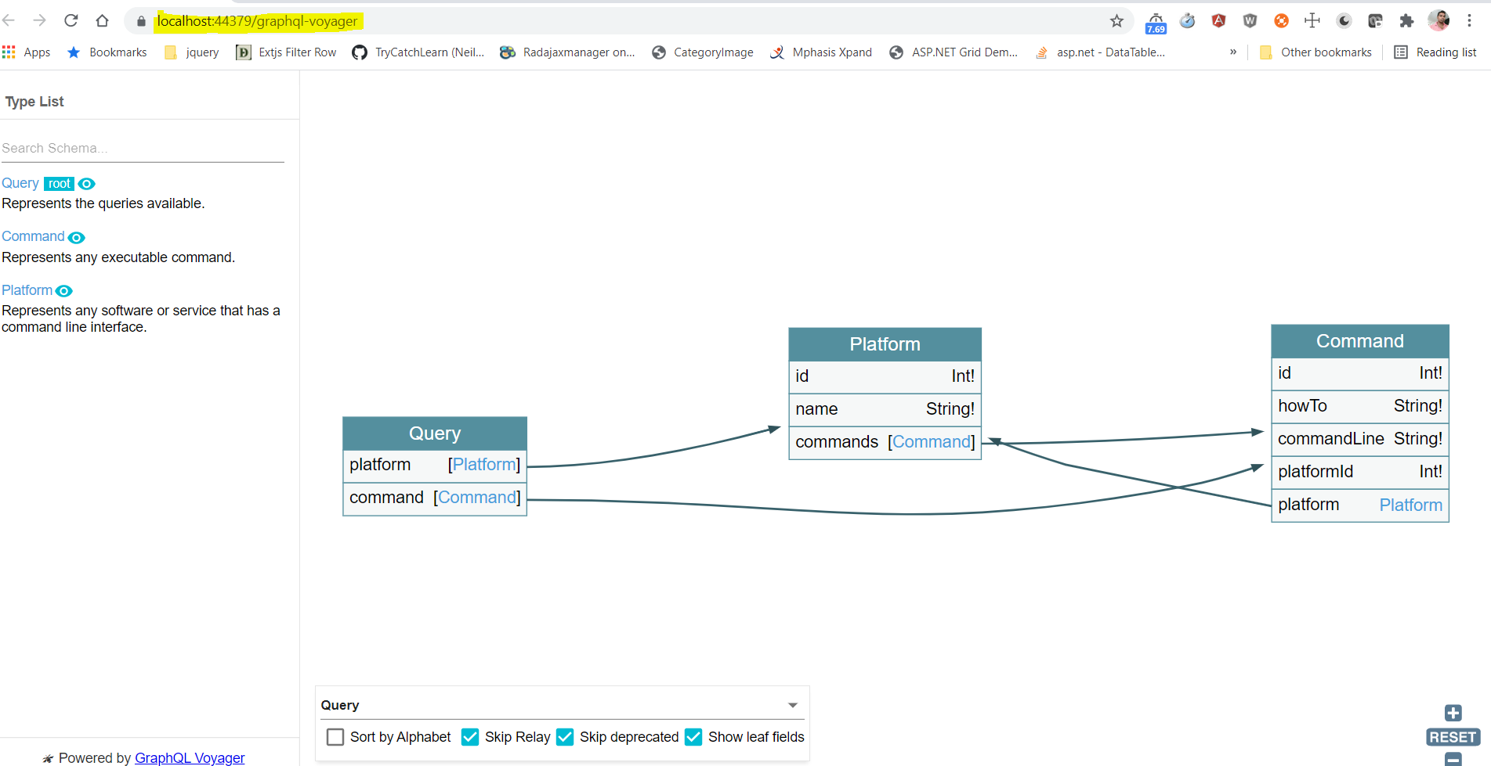

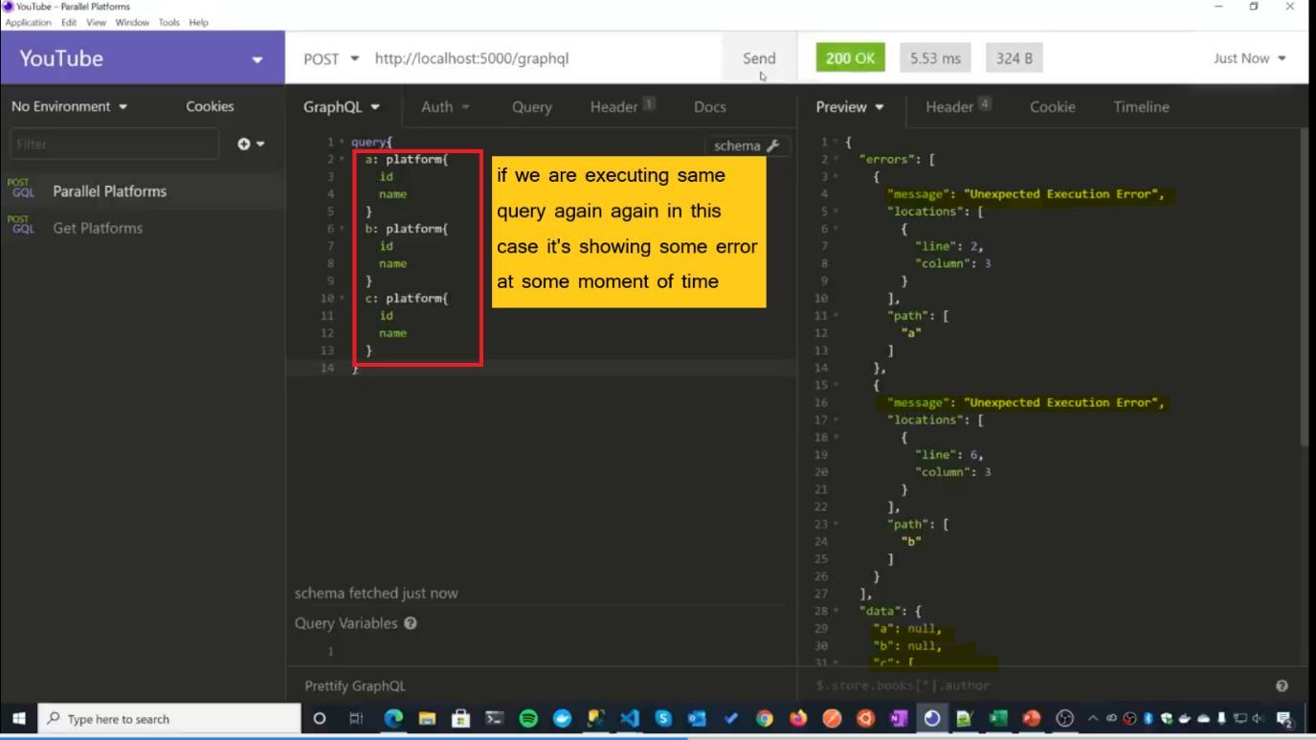**For fixing those error we have to follow below**

**Change No .1: Startup.CS**

Instead of this one

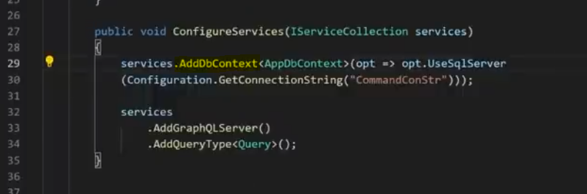

**Use this one**

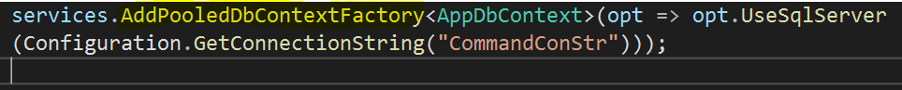

**Change No:2**

**Query Class Instead of this and Change Service to ScopeService**

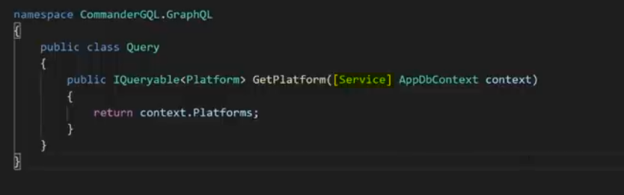

**Add some declaration like below**

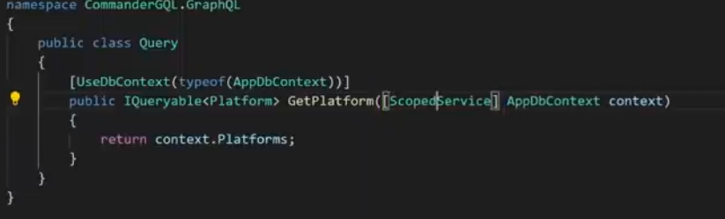

**If your Loading Parent Child Object**

In this case below Child Entity is not loaded

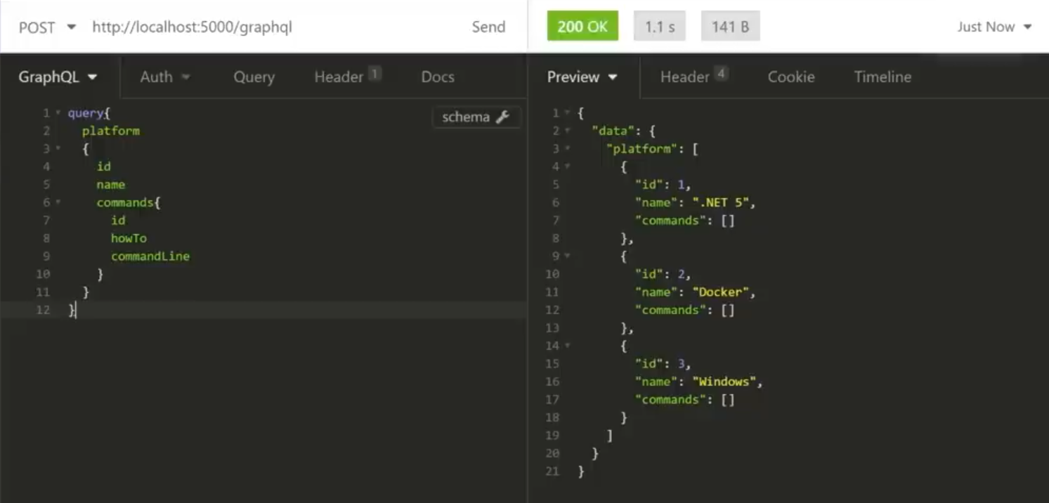

**Solution:**

**Step 1:**

For that we have to **Use Projection** Decorator in the class level

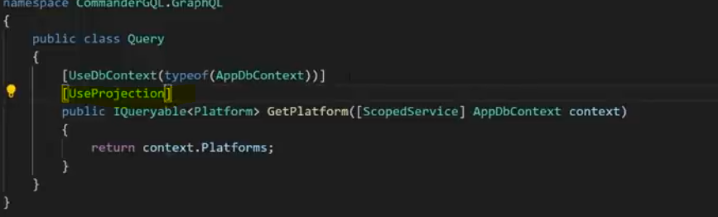

**Step 2:**

**AddProjection** in ConfigureService Method

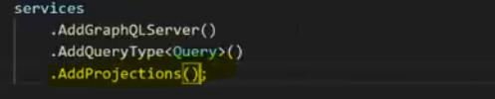

**Errors Resolved**

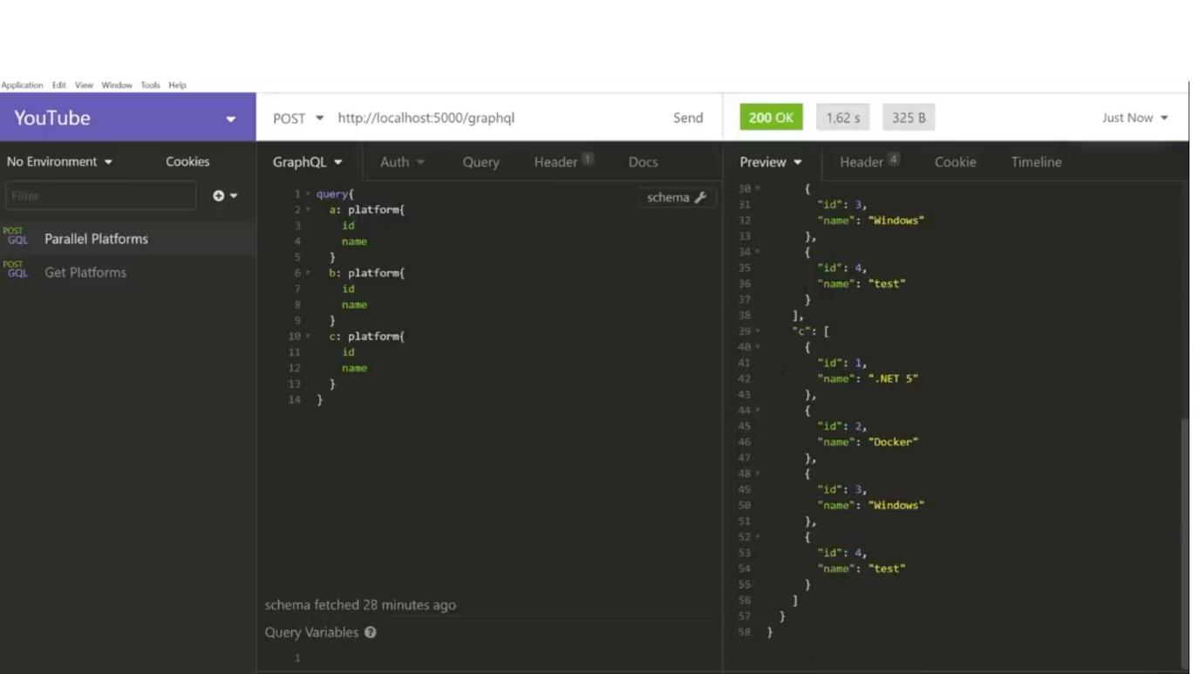

**How To add Documentation for Model Class and Property:**

Using Add **GraphQLDescription** we can add the Documentation for Class Level and Property Level like the below.

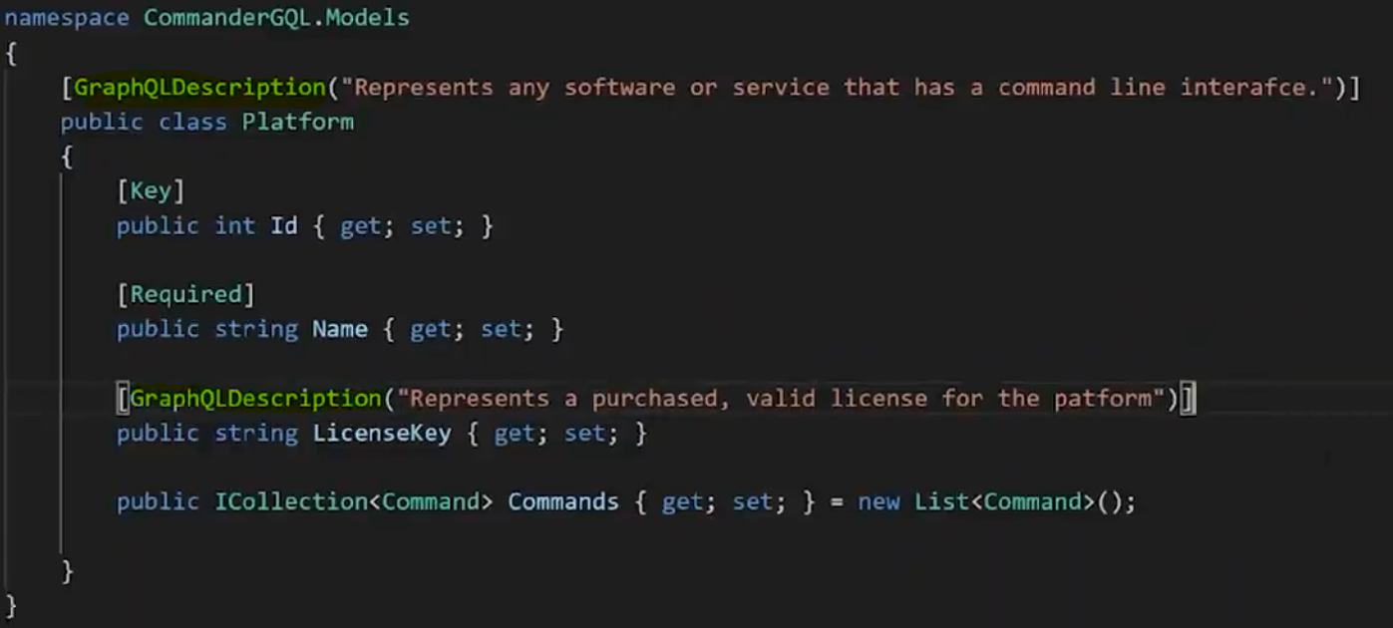

**Result:**

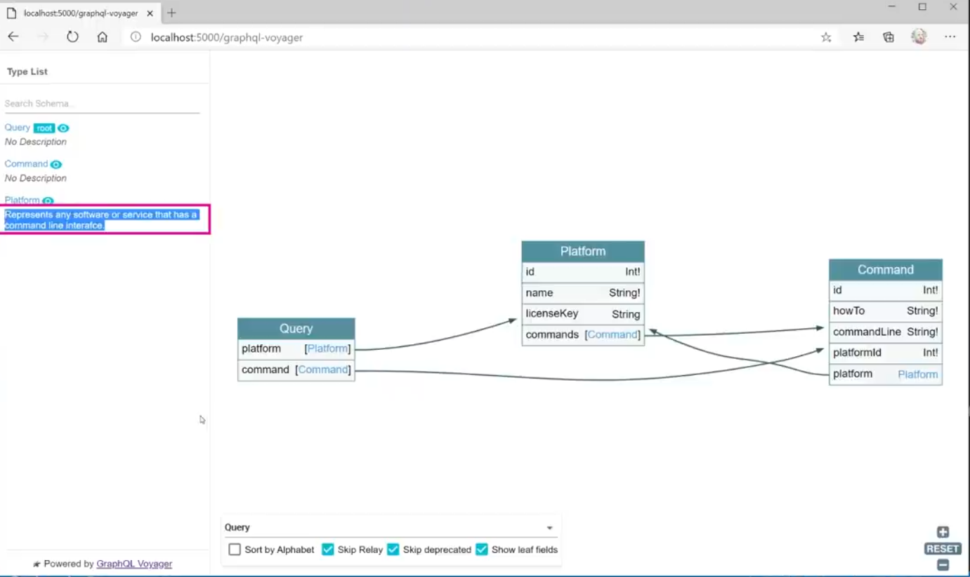

**Problem:**

In case if we are in larger project then we don’t want to add GraphQL Declaration in this model class for that we have to Create **Type using Code First Approaches** for every model then we can Decorate the Property and Class.

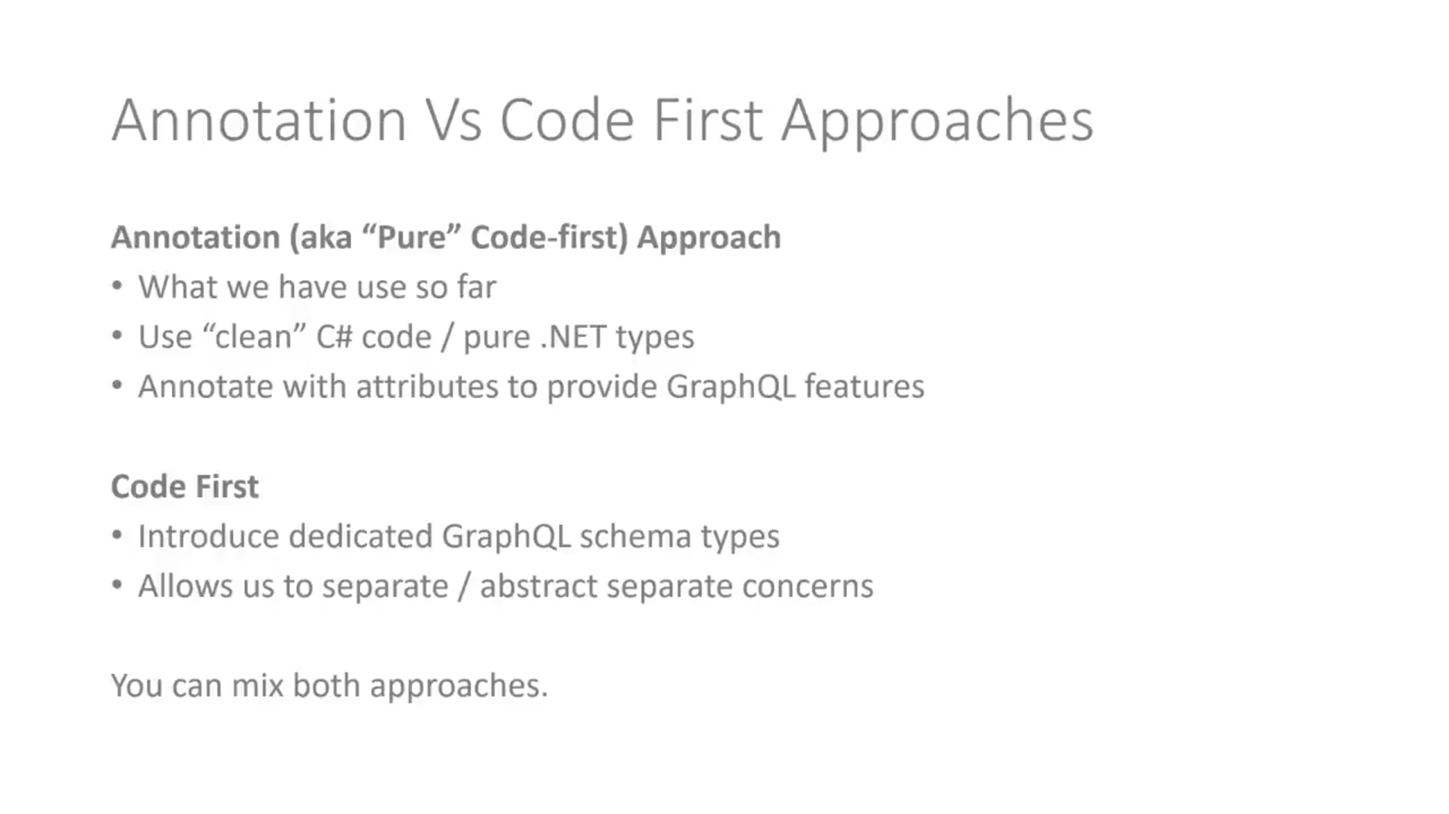

**Where We can use Resolvers**

If we have Parent Child Relation ship and we are following Code First Approach for the Documentation. In Such case we are using Resolvers.

**Step 1:**

If we use Resolvers the we have to **Remove** the **UseProjection** Decorator else our child model not able to load.



**Step 2:**

**Remove** from the **AddProjection Operator in Startup** Class also



**Step 3:**

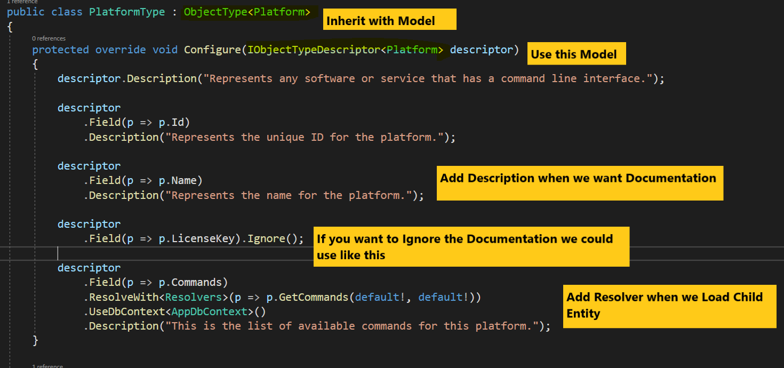

**Step 4:**

For Load Child Entity

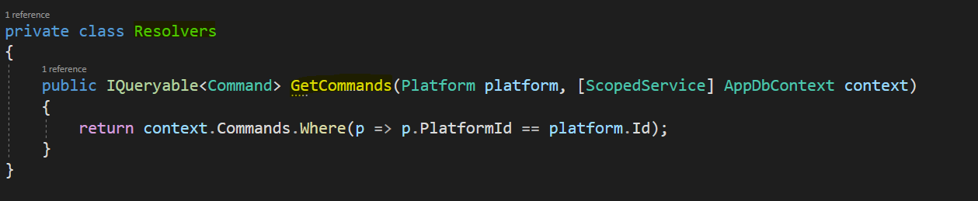

**How to use Filtering and Sorting in GraphQL:**

Follow below example in Query.cs page

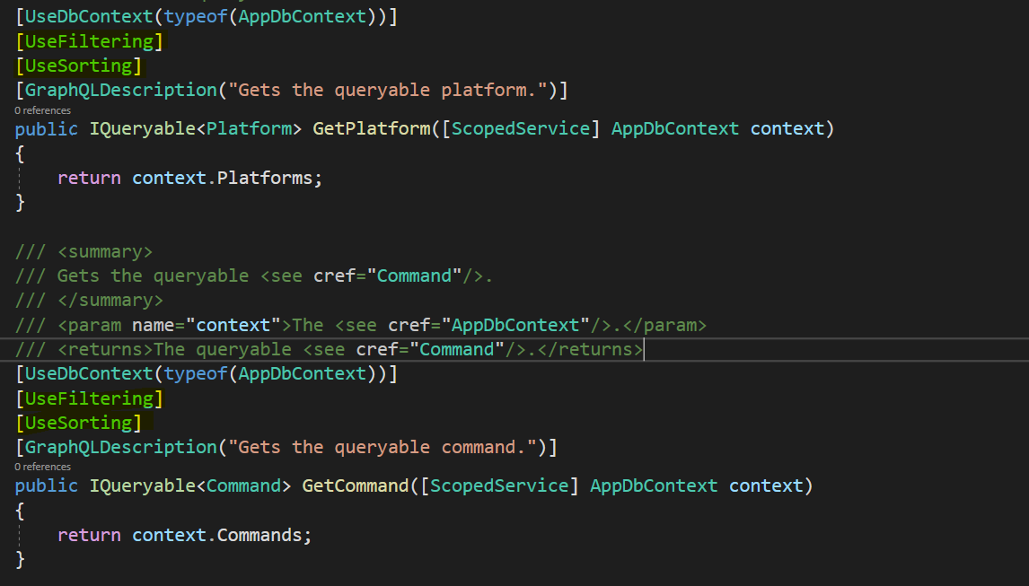

**Using Where Statement:**

query{

command(where:{platformId:{eq:1}}){

platform{

id

name

commands{

id

howTo

commandLine

platformId

}

}

}

}

**Order By Statement:**

query{

platform(order:{name: DESC}){

id

name

}

}  
  
**Result:**

{

"data": {

"platform": [

{

"id": 2,

"name": "Sql Server"

},

{

"id": 3,

"name": "OSX"

},

{

"id": 1,

"name": "Asp.net"

}

]

}

}

**Insert Inserted Object:**

mutation{

addCommand(input:{

howTo:"Perform directory listing"

commandLine:"ls"

platformId:4

})

{

command

{

id

howTo

commandLine

platformId

platform{

name

}

}

}

}

**What is the use of Subscriptions:**

It’s Relay on Web Socket.

If we have some EDelivery Application after the delivery. The management want’s to notify which order has delivered. In such a case we could use Subscriptions.

**Step 1:**

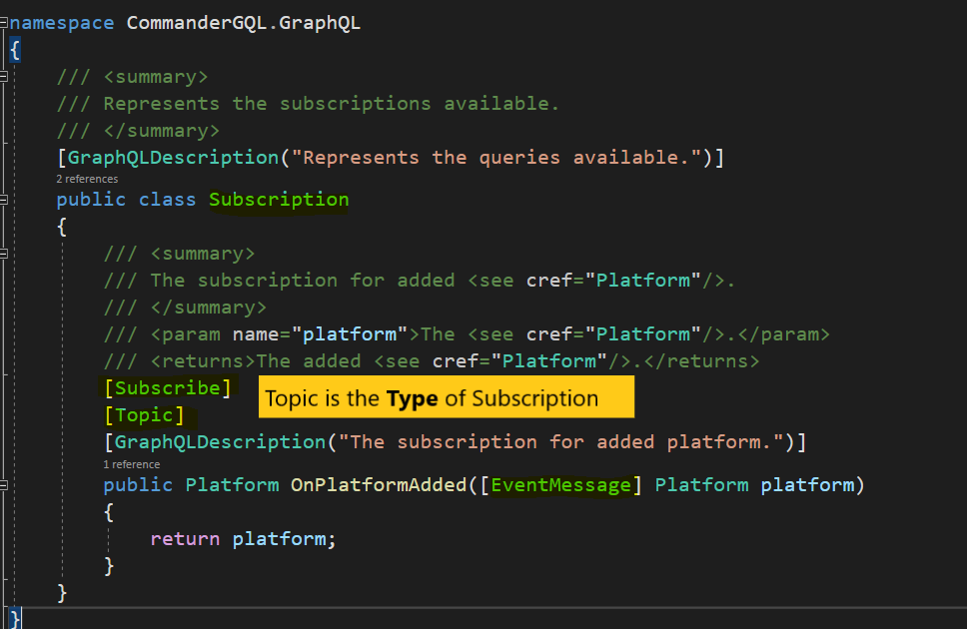

**Step 2:**

Add **app.UseWebSockets()** Method

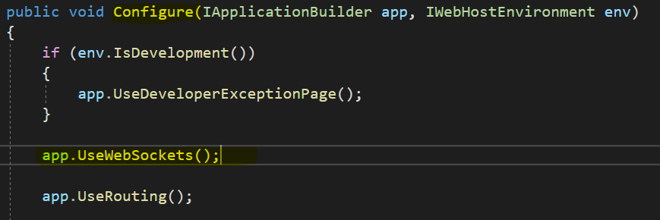

**Step 3:**

Add this **.AddInMemorySubscriptions()** Method under **ConfigureServices**

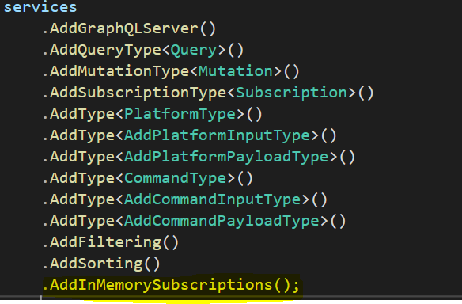

**Step 4:**

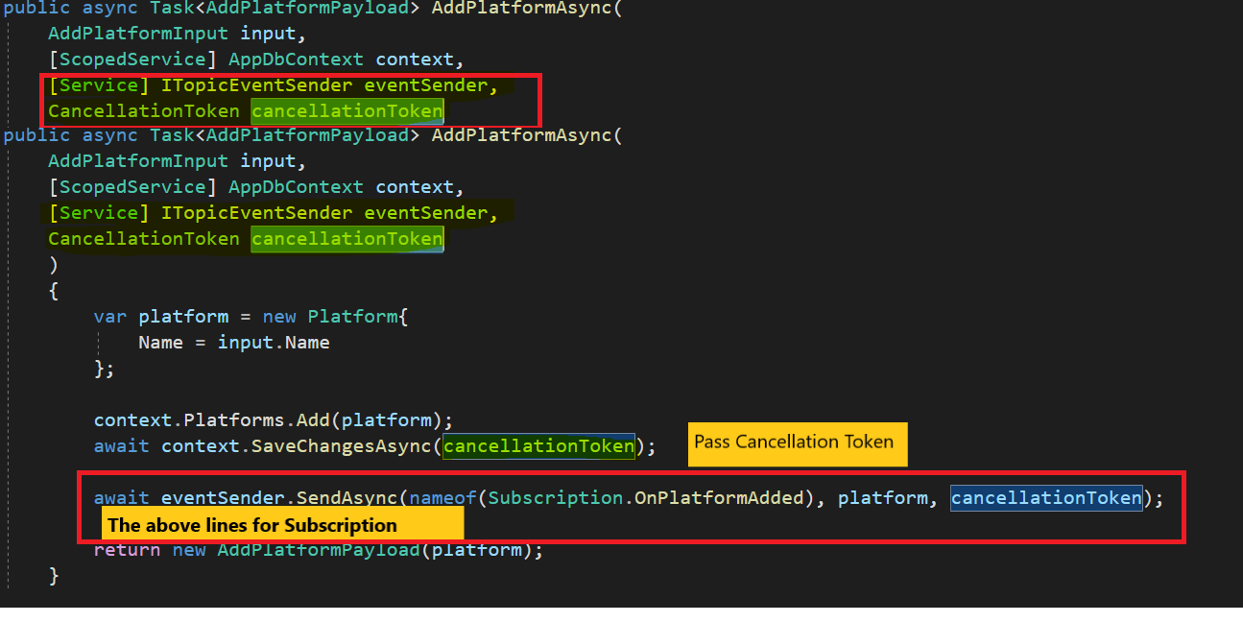

**Step 5(Testing):**

**Step 1(User 1):**

In this step we have to Subscribe then it’s start loading until if some send the value.

In case if some send the value, it will notify

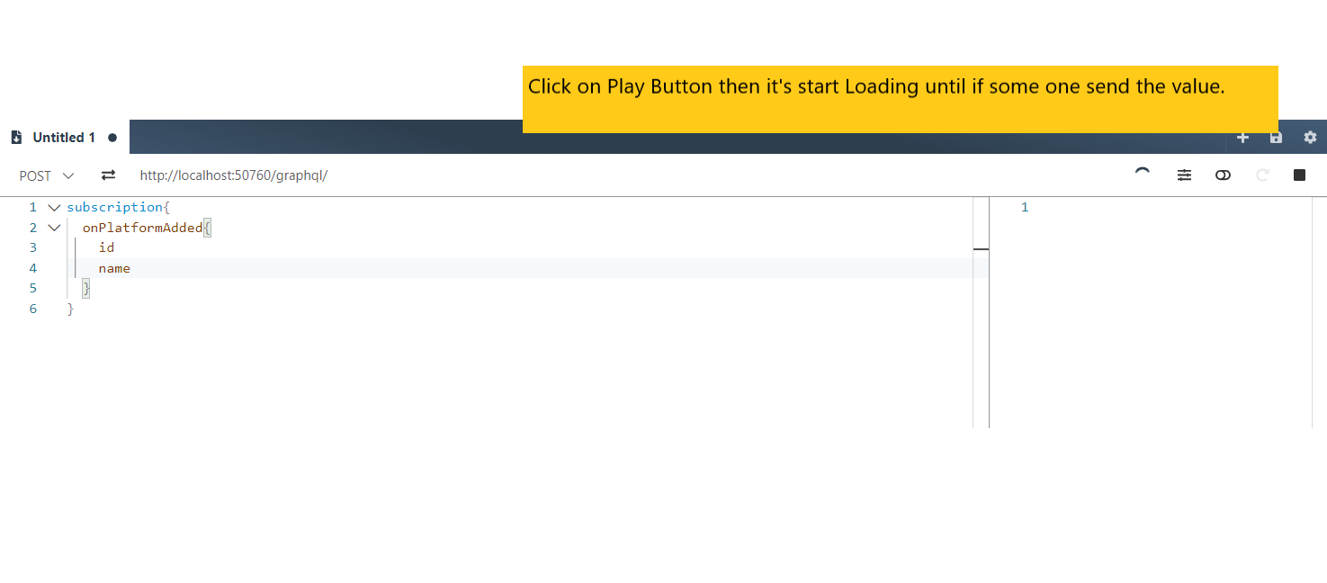

**Step 2:**

User 2 Click Send the Button

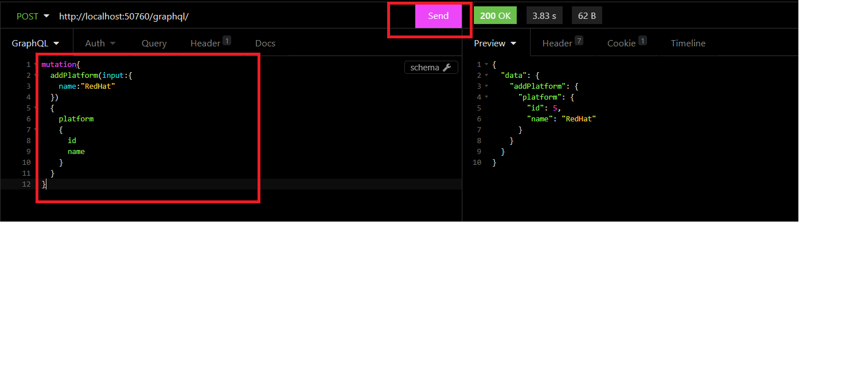

**Step 3:**

In Subscribe Channel we got new value.

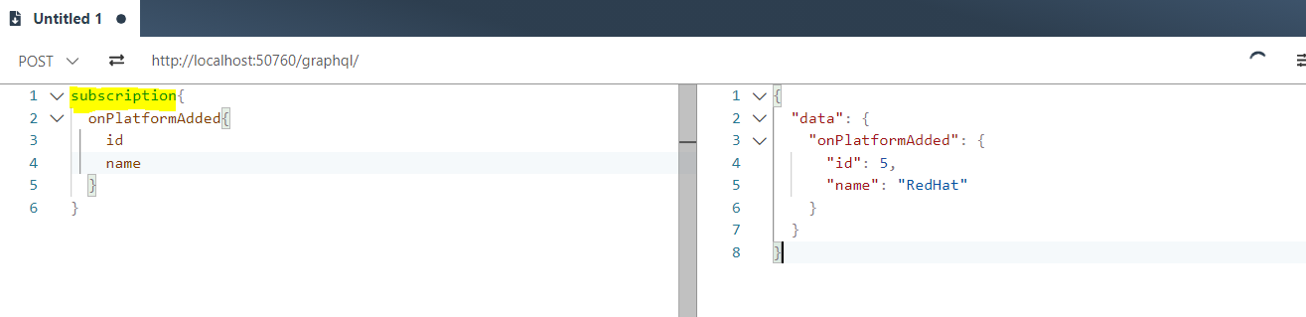

**PayLoad :**

It’s nothing but the Output.

**Query & Mutation:**

* All Query and Mutation we will get Insomaina Tools like given below.
* Insomaina Tools all the request are Post

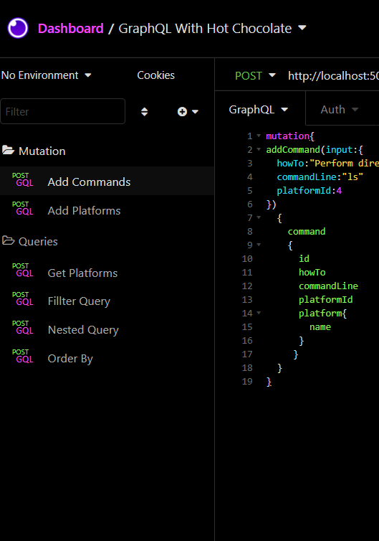

**Reference Project:**

**C:\Study Drive\Practise\Dot Net Core\GraphQL\S04E01---.NET-5-GraphQL-API-main\S04E01---.NET-5-GraphQL-API-main**